Saturday April 30, 2011

West Lafayette, IN

Lunch: 11AM Sale: 1PM

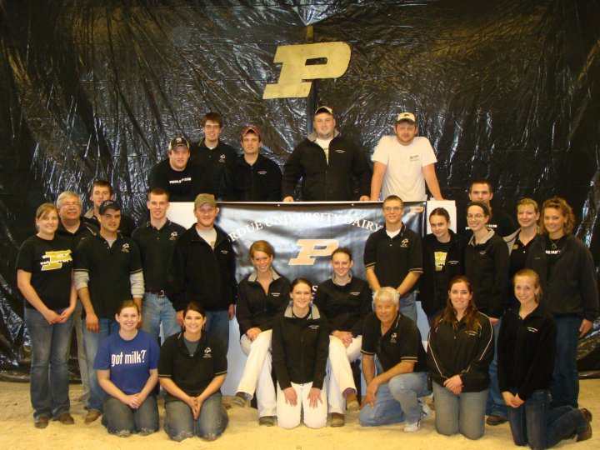

The Boilermaker Heifer Sale



***Boilermaker Heifer Sale***

1:00 PM Saturday April 30, 2011

Purdue University Farms Machine Shed

West Lafayette, Indiana

See map (at back of catalog) for directions.

***Sale Crew:***

Sale Chair Spenser Penrod (260) 224-1013

Co-Chair Ellen Carrell (765) 894-5400

Pedigrees David Blough (574) 825-5094

Auctioneer Merv Leffler (765) 661-5903 AU01016000

Clerks Price-Leffler

Ringman Nathan Kuehnert (260) 437-3776

Ringman Kurt Fischer (765) 585-5183

Ringman Richard Lattire (812) 207-3684

Complimentary Preview Lunch

Starts at 11:00 AM Day of Sale

Boilermaker Heifer Sale Committee:

**Consignments-** Ellen Carrell, Spenser Penrod,

Jordan Eby, Rob LaFollette

**Catalog-** Spenser Penrod, Ellen Carrell

**Preview Lunch** – Allison Springer

**Facilities** – Jeff Fischer

**Barn Crew** – Tyler Myer, Clayton (Wilbur) Snider

**Advisors** – Steve Hendress, Michael Schutz, Nicole Olynk, Tamilee Nennich

**Fitting** – Rob LaFollette

*Special Note: Animals must be removed by 6p.m. sale day.*





**ADM Alliance Nutrition**®

The Boilermaker Heifer Sale is now in its 9th year. Each year, the club has new exciting ideas to improve upon the previous year. Additionally, as this catalog attests to, each year the quality increases. It is our goal to have one of the most elite annual sales in the Midwest. We would like to thank our sponsors: ADM Alliance Nutrition Dairy Solutions & Rich Nisen, North Star Cooperative-Select Sires, and The Farmer’s Exchange. We would also like to thank Price-Leffler Auctioneers for their help with the clerking of our sale. Furthermore, we would like to thank ringmen Richard Lattire, Kurt Fischer and Nathan Kuehnert. We would also like to thank Merv Leffler and David Blough for their work in the box this year. Lastly, the Purdue Dairy Club would like to thank our advisors, Steve Hendress, Nicole Olynk, Tamilee Nennich and Mike Schutz, they have put in a lot of time and energy into this club and we are truly grateful. Best Regards,

Spenser and Ellen

The Dairy Club would like to personally thank Danny Mesmer for donating the halters for the cattle. This is the second year Mr. Mesmer has provided these halters out of his own pocket. It is small donations like this that make this sale possible.

*Boilermaker Heifer Sale*

***The Purdue Dairy Club would like to thank our sponsors:***

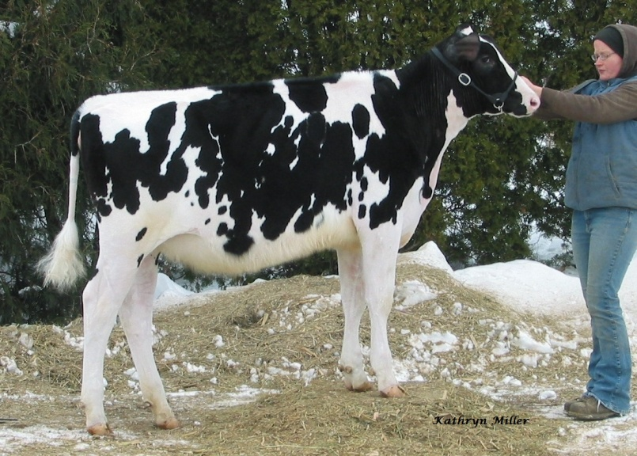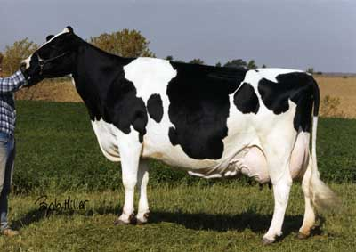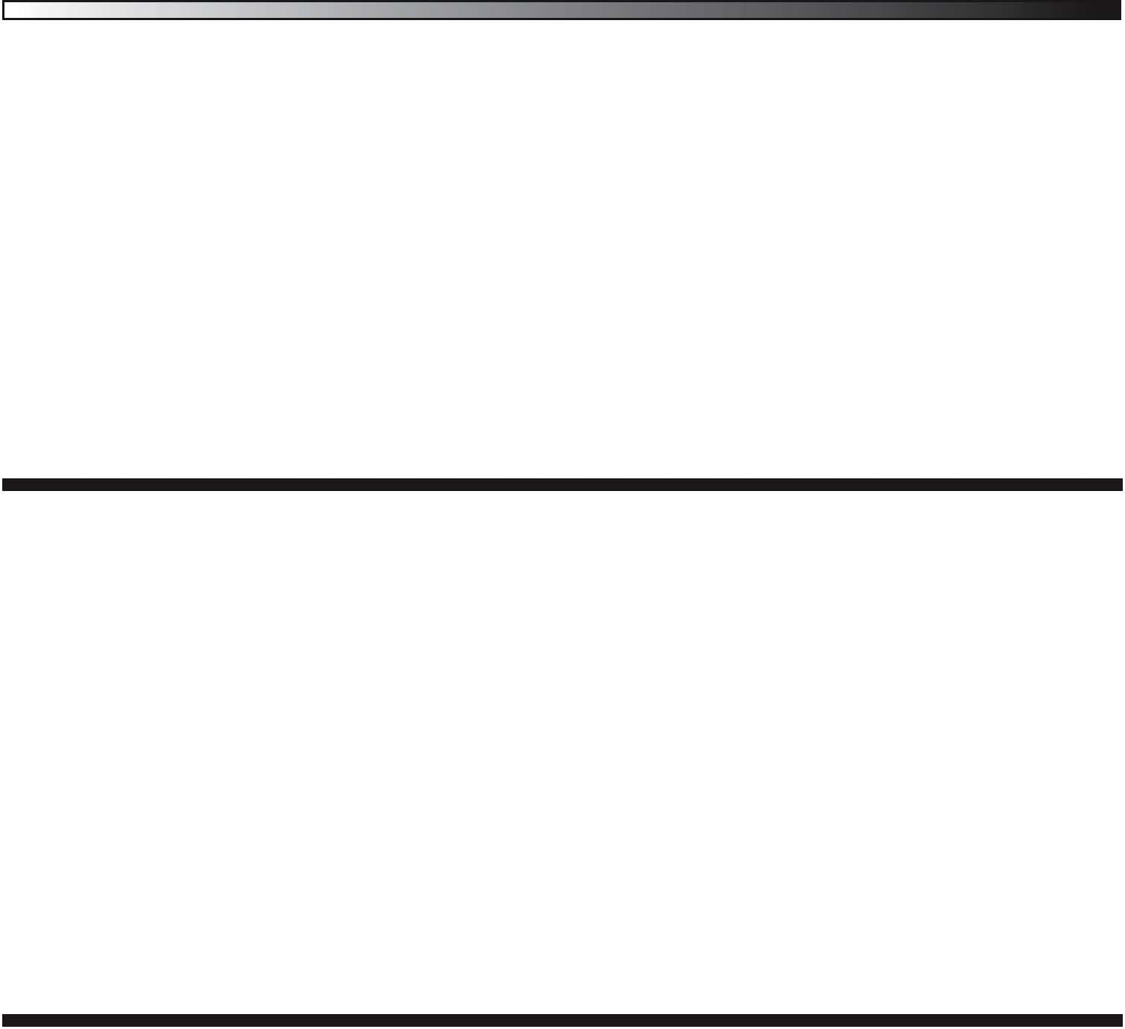

Summer Calf

**Picston Shottle-ET**

GBR 598172

PTA +1334M +63F +36P 99%R 12/10

PTA +510NM +.05%F -.01%P

PTA +3.3PL 2.95SCS -1.0DPR

PTA +2.95T +2.14UDC +1.87FLC

**Mil-R-Mor Marlen Robanna**

USA 134677301 6-02 EX-93 EEEEE 2E

2-03 2x 365 23,570 5.2 1051 3.3 671

3-06 2x 365 28,310 4.9 1387 3.2 906

4-09 2x 365 32,290 4.6 1481 3.3 1061

Life 1581 107,300 5.0 5358 3.4 3666

*1*



**Mil-R-Mor Shottle Rhona-ET**

Born 6/19/2010 USA 140884562

**Carol Prelude Mtoto-ET**

ITA 6001001962 GP-84

PTA +656M +28F +11P 99%R 12/10

PTA +393NM + .01%F -.03%P

PTA +2.7PL 2.46SCS +.9DPR 6%DCE

PTA +.36T +.02UDC +.71FL

**Condon Aero Sharon**

CAN 5373153

**Mil-R-Mor A Marlen**

USA 127558147 EX-92 EVEE 3-07

PTA -897M +16F -11P 64%R 12/10

PTA +115NM +.19%F +.06%P

PTA +1.9PL 2.78SCS -.7DPR

PTA +.7T +.28UDC +.3FL0

**Mil-R-Mor Fargo Robin-ET**

USA 14631460 EX-94 EEEEE 4E

3-03 2x 365 23,070 4.1 956 3.3 771

6-10 2x 365 26,420 3.8 994 3.1 817

8-03 2x 365 31,180 3.9 1211 3.3 1014

Life 2764 175,400 4.1 7232 3.3 5837

*Mil-R-Mor Farms*

*Robert Miller*

*765 E Rock Grove RD*

*Orangeville, IL 61060*

*815-819-7282*

*Mil-R-Mor Shottle Rhona-ET – Sells as Lot 1*

*C Glenridge Citation Roxy EX-97 – 4th Dam of Lot 1*



*Holsteins*

**3rd Dam: Mil-R-Mor Roxy Roberta**

5-07 VG-85 +EEG DOM

LFT 1921 106,820 3.9 4205 3.3 2748

**4th Dam: C Glenridge Citation Roxy**

12-01 EX-97 EEEE 4E GMD

LFT 3620 209,784 4.5 9471

2X Queen of the Breed

**5th Dam: C Norton Court Model Vee**

13-02 EX-90 EEEV

LFT 4183 218



**Crackholm Fever-ET**

CAN 10705608 TV TL

PTA +19M +31F +3P 93%R 12/10

PTA +260NM +.12%F +.01% P

PTA +1.9PL 2.82SCS -.3DPR

PTA +2.77T +1.61UDC +.99FLC

**Star-Summit Durham Brandy**

USA 136952378 4-00 EX-90 VEEEE

2-03 2x 320 31,050 3.9 1206 3.1 963

3-05 2x 365 34,150 3.1 1053 3.2 1076

*2*



**Six (6) #1 DT Embryos**

**Braedale Goldwyn**

CAN 10705608 TV TL

PTA +323M +42F +1323P 99%R 12/10

PTA +474NM +.12%F +.05%P

PTA +2.8PL 2.63SCS +.0DPR 6%DCE

PTA +3.16T +2.44UDC +2.02FL

**Crackholm Emory Fashion**

Can 100385034 EX-92

7-00 2x 327 35,628 4.2 1481 2.7 968

**Regancrest Elton Durham-ET**

USA 2250783 TR CV TL

PTA -288M -36F +5P 99%R 12/10

PTA +27NM -.10%F +.05% P

PTA +.3L 2.89SCS +.2DPR 7%DCE

PTA +2.42T +2.27UDC +2.03FL 99%R 12/10

**Star-Summit Emory Bunny**

USA 133522729 6-08 EX-92 EEEVE 2E

*Mark Van Tuinen*

*2471 4th st*

*Shelbyville, MI 49344*

*517-719-7356*

**Star-Summit Emory Bunny**

2-02 2x 351 27,350 4.4 1212 3.4 926

3-02 2x 344 33,070 4.0 1316 3.3 1079

4-03 2x 365 33,450 3.8 1255 3.2 1061

5-10 2x 322 42,810 3.8 1619 2.9 1254

LFT 1433 138,350 4.0 5468 3.2 4375

**3rd Dam: Star-Summit Lantz Bonita**

3-10 VG-85 +VV+V

2-05 2x 365 27,350 3.8 1027 3.7 1024

3-06 2x 305 28,410 3.7 1038 3.5 985

**4th Dam: Star Summit Juror Bonnie**

EX-91

**5th Dam: Dedicated Tesk Becky**

VG-87

**6th Dam: Lettingas Starbuck Coy Beth**

VG-85

**Maple-Downs-I G W Atwood-ET**

CAN 8956379 VG-87

PTA +515M +51F +24P 76%R

PTA +347NM +.13%F +.03% P

PTA +.9PL 2.84SCS -1.1DPR 7%DCE

PTA +4.23T +2.95UDC +3.26FLC

**Gross-Farm Juror Ship**

USA 121674531 12-02 EX-90 EEEEV 2E

1-09 2x 352 28,200 4.3 1218 2.8 803

5-09 2x 365 49,500 5.0 2480 2.7 1318

7-00 2x 365 44,610 5.8 2607 2.7 1203

10-02 2x 365 40,450 4.6 1861 2.8 1143

Life 3028 301,850 4.7 14137 2.8 8461

*3*



**Four (4) #1 DT Embryos**

**Braedale Goldwyn**

CAN 10705608 TV TL

PTA +323M +42F +1323P 99%R 12/10

PTA +474NM +.12%F +.05%P

PTA +2.8PL 2.63SCS +.0DPR 6%DCE

PTA +3.16T +2.44UDC +2.02FL

**MD-Delight Durham Atlee-ET**

USA 131704103 EX-92-EX-MS DOM  
3-11 2x 365 38,290 5.5 2091 3.1 1177

**Ked Juror-ET**

USA 2124357 10-01 GP-82 +EEP

PTA -141M -10F -9P 99%R 1/10

PTA -70NM -.02%F -.02% P

PTA +.7PL 3.07SCS -.9DPR 9%DCE

PTA +.79T +.95UDC -.97FL

**Gross-Farm Jed Ship**

USA 15686536 2-06 VG-86 VVVVV

2-00 2x 267 25,310 3.9 996 2.6 659

2-11 2x 212 24,170 5.3 1290 2.7 655

*Mark Van Tuinen*

*2471 4th St.*

*Shelbyville, MI 49344*

*517-719-7356*

**3rd Dam: Gross-Farm Thor Sailor**

3-02 GP-80 VVVVF

1-11 2x 277 20,570 4.5 920 2.8 568

2-10 2x 341 31,180 5.7 1788 3.0 920

4-00 2x 365 35,130 4.0 1418 2.9 1013

5-03 2x 353 30,300 4.4 1344 2.8 851

LFT 1441 122,890 4.7 5792 2.9 3516

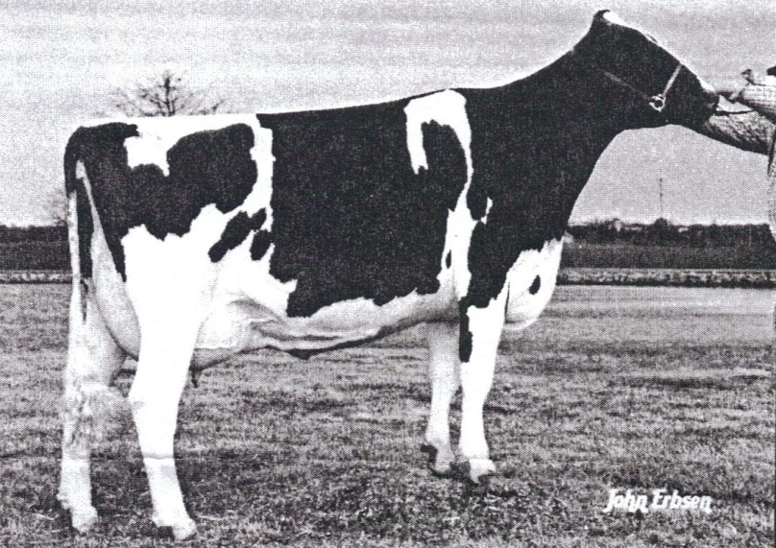 

**Scientific Debonair-Red-ETS**

USA 137892772 3-02 90 EEVV TV TL TD

PTA +589M -6F +21P 76%R 12/10

PTA -8NM -.11%F +.01% P

PTA +2.2PL 3.23SCS -1.9DPR 11%DCE

PTA +2.55T +1.93UDC +1.18FLC

**Lookwell Laramie Leslie**

USA 138276463 3-10 GP-83 +V+G+

*4*



**Lookwell Debonair Luna**

Born 8/7/2010 USA 141123121

**Ladino Park Talent-IMP-ET**

AUS 930377 RC TV TL

PTA -197M -29F +5P 99%R 12/10

PTA -6NM -.08%F +.04%P

PTA +2.6PL 3.16SCS -2.1DPR 10%DCE

PTA +2.08T +2.33UDC +.90FL

**Scientific Debutante Rae-ET**

USA 132416603 4-00 EX-92 EEEEE GMD DOM

2-02 2x 365 32,930 4.4 1191 3.2 863

3-10 2x 208 19,350 5.5 1066 2.9 560

**Wedgwood Laramie-ET**

CAN 8432142 TV TL

PTA -411M -5F -12P 96%R 12/10

PTA -445NM +.04%F +.00% P

PTA -4.8PL 3.08SCS -306DPR 15%DCE

PTA +1.77T +.70UDC +.56FL 94%R 12/10

**REJ Ruben Lilly-ET**

USA 136757517 3-06 GP-84 V+VV+

*Lookwell Farm*

*c/o Jordan Eby*

*62150 CR 3*

*Elkhart, IN 46517*

*574-238-7971*

**3rd Dam: AW Infinity Sandys Ada** EX-91

Summer Calf

*Adler Lindisha Marshall*

*EX-90*

*Dam of Lot 5*

**Dream-Prairie Shadow Boxer**

USA 139086241 2-10 EX-90 EEVE TR TV TL TD

PTA +656M +68F +38P 78%R 12/10

PTA +567NM +.17%F +.07% P

PTA +3.6PL 2.71SCS -.7DPR 8%DCE

PTA +3.29T +2.37UDC +2.57FLC

**Adler Lindisha Marshall**

USA 60437722 6-06 EX-90 EEEVV

3-02 2x 365 29,700 3.8 1127 3.0 898

4-07 2x 365 30,460 3.7 1112 3.0 927

5-10 2x 365 38,960 4.1 1187 3.0 869

7-04 2x 365 22,248 3.9 869 2.9 637

LFT 1807 137,344 4.1 5575 3.1 4216

*5*



**Adler Boxer Lacy 096-ET**

Born 9/22/10 USA 141048149

**Picston Shottle-ET**

GBR 598172

PTA +1334M +63F +36P 99%R 12/10

PTA +510NM +.05%F -.01%P

PTA +3.3PL 2.95SCS -1.0DPR

PTA +2.95T +2.14UDC +1.87FLC

**Regancrest Gold Bretta-ET**

USA 62496942 3-00 VG-88 VEVVV DOM

2-01 3x 365 34,610 4.8 1676 3.6 1249

**Mara-Thon BW Marshall-ET**

USA 2290977 TV TL

PTA +1314M +22F +27P 99%R 12/10

PTA +81NM -.09%F -.05%P

PTA -1.5L 2.91SCS -1.9DPR 8%DCE

PTA +1.60T +1.31UDC +2.05FL 99%R 12/10

**USA 51363982**

Not Classified

3-02 2x 305 24,000 3.6 856 3.1 755

*Melvin Kron*

*5400 Armstrong Rd*

*Evansville, IN 47720*

*812-963-5389*

**Robthom Moscow-ET**

USA 13258764 4-11 EX-93 EEE GM

PTA +986M -2F +14P 99%R 12/10

PTA +247NM -.14%F -.06%P

PTA +2.7PL 2.73SCS +.8DPR 7%DCE

PTA +1.21T +1.38UDC +1.21FLC

**Koester Best Lynn 627**

USA 64902581

Just Fresh-Milking 72# with 4.2 Test (2yr)

*6*



**Koester Moscow Sue 0998**

Born 12/24/2010 USA 141096272

**Mara-Thon BW Marshall-ET**

USA 2290977 TV TL

PTA +1314M +22F +27P 99%R 12/10

PTA +81NM -.09%F -.05%P

PTA -1.5PL 2.91SCS -1.9DPR 8%DCE

PTA +1.60T +1.31UDC +2.05FL 99%R 12/10

**Robthom Georgia Integrity**

USA 15044041 10-02 EX-92 EEEEE 2E GMD DOM

LFT 2235 227,411 4.2 9586 3.2 7374

**Hidden-View Best**

USA 123645630 7-06 EX-94 EEE TV TL

PTA +199M +39F +24P 99%R 12/10

PTA +68NM +.12%F +.07%P

PTA -1.4PL 3.41SCS -2.2DPR 9%DCE

PTA +1.07T +.93UDC +1.91FL

**Koester Damion Kahmaria 471**

USA 62399794

1-11 2x 317 12,911 4.0 518 3.4 443

3.00 2x 365 24,002 4.1 985 3.3 789

*Melvin Kron*

*5400 Armstrong Rd*

*Evansville, IN 47720*

*812-963-5389*

Intermediate Calf

Senior Calf



Intermediate Calf

**Erbacres Damion**

USA 130263722 9-11 EX-95 EEEE TR TV TL TD

PTA -498M -59F +1P 99%R 12/10

PTA -85NM -.15%F +.06% P

PTA -.1PL 2.93SCS -.1DPR

PTA +3.09T +2.10UDC +3.00FLC

**DenwoodLaurin Donelle**

USA 139685299 11/25/2008

*7*



**Denwood Damion Donna**

Born 12/19/2010 No. Pending

**Regancrest Elton Durham-ET**

USA 2250783 7-06 EX-90 EEEV TR CV TL

PTA -288M -35F +5P 99%R 12/10

PTA +27NM +.3PL 2.89 SCS +.2DPR

**Regancrest Encore Dalhia-ET**

USA 124287356 4-03 EX-89 EEEV

2-01 2x 365 29,250 3.3 971 3.1 913

**Den-K Marshall LL Laurin**

USA 132480026 5-07 EX-94 EEE TR TV TL TD

PTA +372M +28F +13P 99%R 12/10

PTA -3NM +.06%F +.01% P

PTA -1.3PL 2.96SCS -1.2DPR 8%DCE

PTA +1.61T +.95UDC +.83FL 97%R 12/10

**Denwood Mr Sam Domino**

USA 137844340 4-04 GP-83 ++VV+

*Denwood Holsteins*

*Dennis & Brad Paulus*

*28430 CR 36 W*

*Elkhart, IN 46517*

*574-862-2322*

**Denwood Mr Sam Domino**

2-01 2x 365 25,950 3.7 964 3.1 805

3-03 2x 365 27,550 3.8 1060 3.1 847

**3rd Dam: Denwood Kent Doreen**

12-01 EX-91 VEVEE 2E

LFT 3995 306,950 3.1 9620 2.9 9006

Senior Calf

Junior Two

**Golden-Oaks St Alexander-ET**

USA 61122837 7-07 EX-93 EEVE TR TV TL TD

PTA +760M +66F +23P 92%R 12/10

PTA +330NM +.14%F +.00% P

PTA +1.4PL 2.88SCS -2.3DPR 9%DCE

PTA +2.37T +1.51UDC +1.86FLC

**Hilltop-DRW Roy Petunia**

USA 139603871 9/1/2008

*9*



**Name & Number Pending**

Born 10/16/2010

**Comestar Stormatic-ET**

CAN 6947936 EX TV TL

PTA +370M -3F +3P 99%R 12/10

PTA +32NM -.07%F -.03%P

PTA +.5PL 3.15SCS -.9DPR 7%DCE

PTA +1.77T +.94UDC +2.02FLC

**Comestar Lausan Black-ET**

CAN 5319830 VG-87 CAN

LFT 1818 108,246 4.4 1587 3.4 3945

**Roylane Jordan-ET**

USA 17064727 TV TL

PTA -646M -9F -14P 99%R 12/10

PTA -94NM +.01%F -.01% P

PTA -2.0PL 3.10SCS +.0DPR 6%DCE

PTA +1.96T +1.90UDC +.22FLC

**Hilltop-RJ Blithe Tami PJ**

USA 136346157 5-01 VG-85 V+GVV

2-05 2x 305 20,510 3.7 761 3.2 651

3-05 2x 296 31,960 3.3 722 3.1 675

4-05 2x 295 25,390 3.3 850 3.2 813

*Douglas Wicker*

*4046 Skating Rink Rd.*

*Milroy, IN 46156*

*765-629-2206*

**Fradon Jet-Red-ET**

CAN 7825836 TL

PTA -626M -32F -15P 71%R 4/10

PTA -20NM -.03%F +.02% P

PTA +2.5PL 2.95SCS +.8DPR 9%DCE

PTA +1.31T +1.27UDC -.41FLC

**Astrahoe Jo RNR Rose-Red**

USA 62313576 2-06 VG-85 +V+VV

2-01 2x 323 25,030 3.0 751 3.0 747

*8*



***MS Wintrfield Jet Ronna-Red***

*Born 3/2/2009 USA 3005685946*

*Bred 9/14 to Aggravation Lawn Boy P-Red*

**Ladino Park Talent-IMP-ET**

AUS 930377 RC TV TL

PTA -197M -29F +5P 99%R 12/10

PTA -6NM -.08%F +.04%P

PTA +2.6PL 3.16SCS -2.1DPR 10%DCE

PTA +2.08T +2.33UDC +.90FL

**Fradon R Mark Jodie-Red**

CAN 8237577 EX-91 CAN 2E

4-10 2x 365 31,640 3.7 1162 2.8 890

**Pinehurst Rocknroll-Red-ET**

USA 130154521 TL

PTA -1696M -88F -45P 99%R 12/10

PTA -301NM -.11%F +.02%P

PTA +.8PL 2.79SCS +.7DPR

PTA -.53T -.22UDC -1.12FLC

**Astrahoe RM Rosa Revlon-ET**

USA 130894429 5-03 VG-85 VVV++

2-05 2x 305 22,110 2.9 643 2.9 632

*Douglas Wicker*

*4046 Skating Rink Rd.*

*Milroy, IN 46156*

*765-629-2206*

**5th Dam: Pinehurst Sweet Cleo**

EX-90

**6th Dam: Pinehurst Sweet Freedom**

EX-90  
**7th Dam: Pinehurst Sweet Delight**

EX-91

**8th Dam: Pinehurst Rapture**

EX-96 GMD

**9th Dam: Pinehurst Fragrance**

EX-90

**10th Dam: Hayssen Fond Ariel**

EX-90

**11th Dam: Hayssen D V Audrey**

EX-90

**12th Dam: Whirlhill Q Rag Apple Ariel**

EX-92

**13th Dam: Arlite Posch**

EX-92 GMD

**14th Dam: Audrey Posch**

EX-92 GMD

**3rd Dam: Pinehurst Royal Rosa-ET**

EX-91

**4th Dam: Pinehurst Roulade**

EX-92

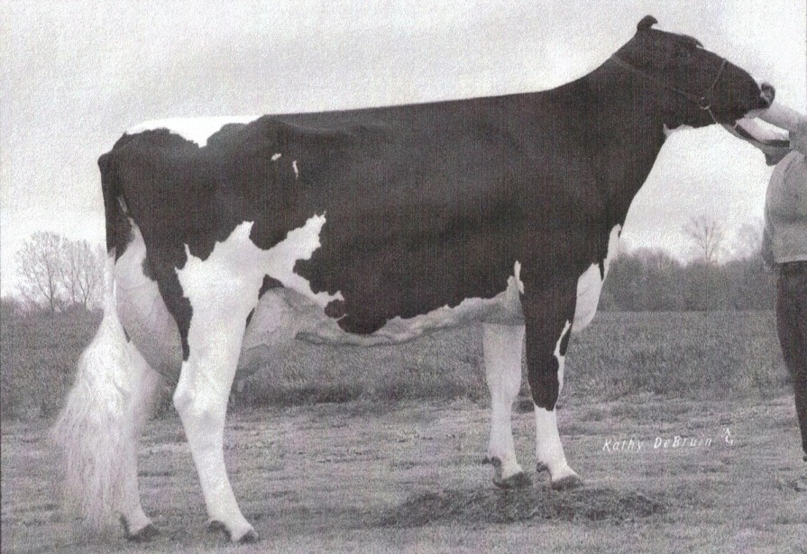

Senior Two

**Fradon Inferno-Red-ET**

CAN 8793411 TV TL

PTA -3879M -27F -88P 98%R 12/10

PTA -482NM +.52%F +.13% P

PTA -2.3PL 2.99SCS +2.3DPR 12%DCE

PTA +.15T -.35UDC -.26FLC

**Elmyra R+R Hannah-Red**

USA 135794238 4-01 VG-88 EVGVE

1-08 2x 365 23,030 3.8 871 3.3 752

2-11 2x 365 24,890 4.2 1043 3.3 821

4-02 2x 179 16,610 4.2 702 3.0 504

*11*



**Elmyra Inferno Hazel-Red**

Born 12/20/2008 USA 139710436

*Bred 5/5/2010 to Fradon Redliner-Red-ET Due 5/12/2010*

**Markwell Kite-ET**

USA 128460878 RC TV TL

PTA -1284M -28F -39P 99%R 12/10

PTA -451NM +.08%F +.00%P

PTA -2.5PL 3.16SCS -1.3DPR 13%DCE

PTA +1.98T +1.12UDC +.08FL

**Fradon Broker Marigold-ET**

CAN 5497184 EX 4E CAN

LFT 2351 157,796 5.5 8688 3.7 5780

**Pinehurst Rocknroll-Red-ET**

USA 130154521 TL

PTA -1696M -88F -45P 99%R 12/10

PTA -301NM -.11%F +.02%P

PTA +.8PL 2.79SCS +.7DPR

PTA -.53T -.22UDC -1.12FLC

**Elmyra Gerome Holly-Red**

USA 132095705 Not Classified

1-08 2x 336 15,130 4.1 625 3.3 499

2-09 2x 94 2,820 3.7 105 2.6 72

*Elroy G. Miller*

*66220 CR 37*

*Millersburg, IN 46543*

*574-642-3694*

**3rd Dam: Toddsdale Astro Jet Magic**

9-06 EX-92 3E EEEEE

**4th Dam: Miss Schruppdale Magic**

EX-92 3E EEEEE

**5th Dam: Schruppdale Prestar Marvel**

EX-94 3E EEEE

**6th Dam: Timberedge Precise Mabel**

EX-91 3E EEVE

**4th Dam: Timberedge Elector Milly**

EX-91 3E

**Gillette Jordan-ETS**

CAN 7588022

PTA +60M +35F +23P 94%R 12/10

PTA +464NM +.05%F +.02% P

PTA +3.4PL 2.64SCS -.3DPR 6%DCE

PTA +2.49T +1.76UDC +1.63FLC

**Balsy-Haven Outside Majic**

USA 61122020 EX-94 2E EEEEE

2-11 2x 365 26,890 4.2 1132 3.2 866

4-04 2x 365 39,720 3.9 1545 3.1 1225

6.00 2x 365 37,000 4.7 1738 3.1 1138

LFT 1586 134120 4.2 6995 3.2 4264

*10*



**Five (5) #1 Embryos**

**Braedale Goldwyn**

CAN 10705608 TV TL

PTA +323M +42F +1323P 99%R 12/10

PTA +474NM +.12%F +.05%P

PTA +2.8PL 2.63SCS +.0DPR 6%DCE

PTA +3.16T +2.44UDC +2.02FL

**Gillette-I Durham Jerico**

CAN 8143479

**Comestar Outside-ET**

CAN 6026421

PTA +221M +33F -5P 99%R 12/10

PTA +293NM +.08%F +.03% P

PTA +4.5PL 2.97SCS +1.1DPR 10%DCE

PTA +1.46T +1.05UDC +.52FL

**Stuartvale A Lindy Magic-ET**

USA 126469312 5-04 EX-91 2E EEEVE

5-07 2x 356 34,390 3.8 1312 3.2 1094

7-08 2x 363 35,580 3.9 1381 3.1 1089

*Springbrook Farms*

*Mike & Todd Jones*

*1307 E 450 N*

*Marshall, IN 47859*

*765-562-2955*

*Balsy-Haven Outside Majic*

***EX-94 2E Ex-95 MS***

***Dam of Lot 10***



**Shoremar James**

CAN 5902195 GP-81 CAN 2yr TV TL

PTA -613M +7F +5P 99%R 12/10

PTA -111NM +.12%F +.09% P

PTA -3.3PL 2.92SCS -2.3DPR 8%DCE

PTA +.71T +.69UDC -.01FLC

**Braedale Baler Twine-ETS**

CAN 6860888 VG-86 CAN 2yr TL

2-01 2x 365 30,906 4.9 1521 3.2 993

*12*



**Five (5) Units of Braedale Goldwyn**

CAN 10705608

**Mark CJ Gilbrook Grand-ET**

CAN 393207 VG-86 CAN 5yr TM TL

PTA -596M +8F -10P 99%R 12/10

PTA -285NM +.12%F +.03%P

PTA -5.2PL 3.02SCS -2.1DPR 11%DCE

PTA +.44T +.50UDC -1.43FLC

**Stelbro Jenine Aerostar**

CAN 5337384 VG-85 CAN 4yr

3-11 2x 365 31,574 3.0 946 3.0 948

**Maughlin Storm-ET**

CAN 5457798 EX CAN TV TL

PTA -63M +26F -3P 94% 12/10

PTA +91NM +.11%F +.00%P

PTA +.1PL 2.77SCS -1.5DPR 10%DCE

PTA +1.12T +.74UDC +1.47FLC

**Braedale Gypsy Grand**

*David Byers*

*6521 N 450 W*

*West Lafayette, IN 47906*

*765-404-8909*

**Braedale Gypsy Grand**

CAN 5912235 VG-88 CAN 5yr

1-11 2x 365 31,277 4.6 1435 3.1 977

5-06 2x 365 34,786 4.8 1660 3.1 1069

LFT 1782 116,398 4.9 5677 3.4 3996

**Note: *The semen will be present at the sale. Please arrange to take delivery of semen on day of the sale!***

**Golden-Oaks St Alexander-ET**

USA 61122837 7-07 EX-93 EEVE TR TV TL TD

PTA +760M +66F +23P 92%R 12/10

PTA +330NM +.14%F +.00% P

PTA +1.4PL 2.88SCS -2.3DPR 9%DCE

PTA +2.37T +1.51UDC +1.86FLC

**Oneeda Wildman Jess**

USA 138658382 3-06 VG-87 VV++V

2-01 3x 350 30,590 4.4 1357 2.9 894

*14*



**Oneeda Alexander Jade**

Born 12/7/2010 USA 69890206

**Comestar Stormatic-ET**

CAN 6947936 EX TV TL

PTA +370M -3F +3P 99%R 12/10

PTA +32NM -.07%F -.03%P

PTA +.5PL 3.15SCS -.9DPR 7%DCE

PTA +1.77T +.94UDC +2.02FLC

**Comestar Lausan Black-ET**

CAN 5319830 VG-87 CAN

LFT 1818 108,246 4.4 1587 3.4 3945

**Ladys-Manor Wildman-ET**

USA 130803069 TV TL

PTA +1518M +33F +40P 99%R 12/10

PTA +245NM +.15%F +.03%P

PTA +.8PL 3.05SCS -1.3DPR 9%DCE

PTA +1.09T +.57UDC -.26FLC

**Oneeda Achiever Jules**

USA 135075317 5-05 VG-86 VVV+V

2-05 3x 365 29,370 3.3 980 2.7 783

5-10 3x 311 34,700 3.7 1280 2.7 924

LFT 1376 121,920 3.7 4487 2.7 3329

*Oneeda Farms, LLC*

*Joe Hibschman*

*71950 CR 35*

*Syracuse, IN 46567*

*574-457-2310*

Intermediate Calf

Intermediate Calf

**4th Dam: Mar-Sel Stardust Jessie**

EX-90 3E

5-10 3x 302 32,540 402 1351 2.7 893

**Erbacres Damion**

USA 130263722 9-11 EX-95 EEEE TR TV TL TD

PTA -498M -59F +1P 99%R 12/10

PTA -85NM -.15%F +.06%P

PTA -.1PL 2.93SCS -.1DPR 6%DCE

PTA +3.09T +2.10UDC +3.00FLC

**AW Blitx Samira**

USA 65508455 Not Classified

*13*



**AW Damion Scarlett**

Born 12/16/2010 USA 69999098

**Fustead Emory Blitz-ET**

USA 2250783 7-06 EX-90 EEEV TR CV TL

PTA -288M -35F +5P 99%R 12/10

PTA +27NM -.10%F +.05%P

PTA +.3PL 2.89SCS +.2DPR 7%DCE

PTA +2.42T +2.27UDC +2.03FLC

**Regancrest Encore Dalhia-ET**

USA 124287356 4-03 VG-89 EEEEV

2-01 2x 365 29,250 3.3 971 3.1 913

**Fustead Emory Blitz-ET**

USA 17013604 12-06 EX-95 TV TL

PTA +1917M +15F +9P 99%R 12/10

PTA +32NM -.20%F -.18%P

PTA +.4PL 3.05SCS -2.9DPR 8%DCE

PTA +1.48T +1.22UDC +.90FLC

**AW Leduc Sandra**

USA 60164830 5-07 GP-83 +VV++

*AW Holsteins*

*4343 W 750 S*

*Rushville, IN 46173*

*765-629-2364*

**AW Leduc Sandra**

1-11 2x 292 18,210 4.0 764 3.2 576

2-11 2x 299 19,600 4.3 851 3.4 673

3-11 2x 305 22,820 4.1 944 3.3 744

5-02 2x 305 23,220 4.2 966 3.2 745

6-02 2x 277 22,780 3.8 874 3.0 674

LFT 1579 112,840 4.1 4623 3.2 3634

**3rd Dam: AW Summun Sandys Sarrann**

VG-89

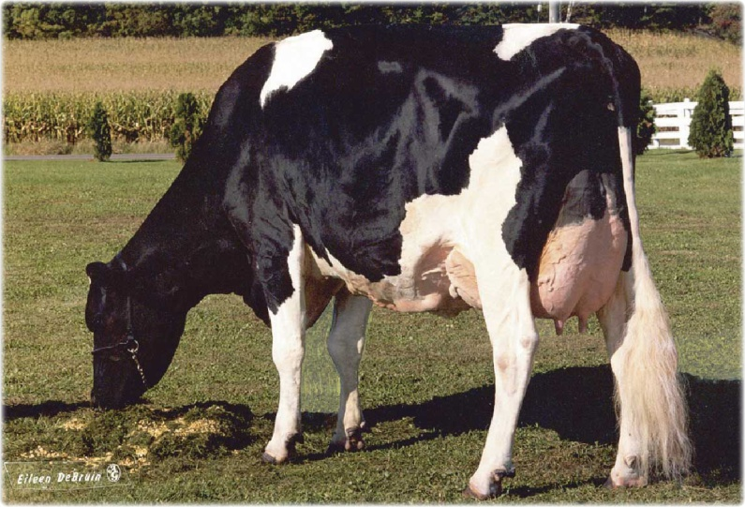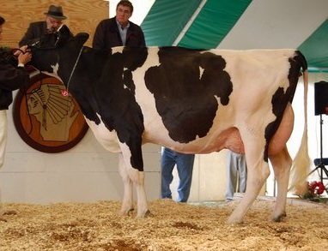

**Penn-Gate Finest-ET**

USA 60540336 3-11 VG-88 VVEV TV TL

PTA -510M -47F -15P 99% 12/10

PTA +146NM -.11%F +.00%P

PTA +3.6PL 2.70SCS +1.7DPR 7%DCE

PTA +1.73T +2.06UDC +2.21FLC

**Indianhead Tripoly-ET**

USA 137413669 4-04 EX-91 EEEEE TR

2-00 3x 323 27,020 4.1 1098 3.0 805

3-00 3x 365 36,900 4.0 1468 3.1 1134

*15*



**Five (5) #1 DT Embryos**

Flushed With Sexed Semen –Excellent Conception Rates

**Regancrest Elton Durham-ET**

USA 2250783 7-06 EX-90 EEEV TR CV TL

PTA -288M -35F +5P 99%R 12/10

PTA +27NM -.10%F +.05%P

PTA +.3PL 2.89SCS +.2DPR 7%DCE

PTA +2.42T +2.27UDC +2.03FLC

**Penn-Gate Skychief Finesse**

USA 15790548 9-02 EX-95 EEEEE 3E DOM

LFT 2245 161,510 4.5 7311 3.3 5285

**Braedale Goldwyn**

CAN 10705608 TV TL

PTA +323M +42F +1323P 99%R 12/10

PTA +474NM +.12%F +.05%P

PTA +2.8PL 2.63SCS +.0DPR 6%DCE

PTA +3.16T +2.44UDC +2.02FL

**Indianhead Trilogy**

USA 128266531 5-03 EX-94 EEEEE

*Indianhead Holsteins*

*Robert Schauf*

*1659 10 ½ St.*

*Barron, WI 54812*

*715-537-9376*

**Indianhead Trilogy**

2-03 3x 355 27,410 4.2 1164 2.9 801

3-06 3x 365 38,700 4.4 1696 2.8 1082

4-09 3x 365 42,620 3.9 1663 2.8 1183

LFT 1262 123,530 4.2 5171 2.9 1183

**3rd Dam: Indianhead Milan Tina-ET**

USA 17396838 9-04 EX-92 EEVVE 3E

LFT 2803 261,950 3.9 10188 3.0 7970

**4th Dam: C Alanvale Inspiration Tina**

EX-95 GMD DOM

*Note:*

*Buyer Pays Shipping ($35-45)*

*Lead Mae EX-95 3E-3rd Dam of Lot 16*

*Indianhead Tripoly-ET EX91-Dam of Lot 15*

**Regancrest Dundee-ET**

USA 127640114 6-08 EX-95 EEEV

PTA -445M -24F -8P 99%R 12/10

PTA -161NM -.03%F +.02%P

PTA +2.02PL 3.06SCS -.3DPR 9%DCE

PTA +2.02T +2.19UDC +.91FL

**Indianhead Marshal Mamie-ET**

USA 136102036 3-03 VG-88 VVVVE

2-02 3x 365 35,010 3.4 1193 2.7 962

*16*



**4 #1 DT Embryos**

**Marcrest Encore**

USA 2048702 9-04 EX-96 EEEE TV TL

PTA -905M -24F -27P 99%R 12/10

PTA -346NM +.04%F +.00%P

PTA -2.0PL 3.23SCS -.4DPR 14%DCE

PTA +1.03T +.65UDC -.25FL

**Snow-N Denises Dellia**

USA 12895802 7-08 EX-95 EEEEE 2E GMD DOM

LFT 3558 180,240 3.9 7108 3.2 5723

**Mara-Thon BW Marshall-ET**

USA 2290977 TV TL

PTA +1314M +22F +27P 99%R 12/10

PTA +81NM -.09%F -.05%P

PTA -1.5L 2.91SCS -1.9DPR 8%DCE

PTA +1.60T +1.31UDC +2.05FL 99%R 12/10

**Mayerlane-SA Sky Mae-ET**

USA 132823144 5-07 EX-93 EEEVE DOM

2-04 3x 305 28,810 3.8 977 2.9 750

3-04 3x 365 34,560 3.7 1263 2.9 1019

4-09 3x 319 33,600 3.6 1221 2.9 983

LFT 1107 102,240 3.7 3804 3.0 3034

*Indianhead Holsteins*

*Robert Schauf*

*1659 10 ½ St.*

*Barron, WI 54812*

*715-537-9376*

**3rd Dam: Whitter-Farms Lead Mae-ET**

USA 14524115 9-00 EX-95 EEEEE 3E GMD DOM

LFT 1613 126,960 4.3 5473 3.4 4356

**4th Dam: Raymau Bstar Monica-ET**

VG-89 DOM

**5th Dam: Juniper Jason Maria-ET**

VG-87 DOM

**6th Dam: JDM Pride Valiant Maggie**

EX-91 GDM DOM

**7th Dam: La-Ko-Land Penstate Sadie**

VG-87 GDM DOM

**8th Dam: La-Ko-Land Bootmaker Sally**

VG-86

**9th Dam: La-Ko-Land Monitor Nancy**

EX-90



Senior Calf

**Navs Shari Marico-ET**

USA 64572399 TR TV TL TD

PTA -147M +30F -6P 81%R 12/10

PTA +373NM +.13%F +.00%P

PTA +3.7PL 2.81SCS +.6DPR 5%DCE

PTA +3.60T +3.75UDC +2.75FLC

**Nor-Bert Steamroller Sandy**

USA 62487955 5-04 VG-85 EVV++

2-04 2x 365 27,910 4.0 1107 2.9 813

3-09 2x 365 26,670 4.0 1076 3.0 787

*17*



**Nor-Bert Marico Sophie**

Born: 10/1/2010 USA 69917708

**Regancrest-HHF Mac-ET**

USA 60540164 6-01 EX 92 EEEV TV TL

PTA +168M +16F +2P 99%R 12/10

PTA +327NM +.03%F -.01%P

PTA +3.0PL 2.92SCS +1.4DPR 4%DCE

PTA +2.05T +2.42UDC +1.61FLC

**UFM-Dubs Shari-ET**

USA 62658240 2-06 VG-87 VEV+V DOM

2-00 3x 365 31,440 4.5 1424 3.3 1030

**Nor-Som Steamroller-ET**

USA 128509061 TV TL TD

PTA +174M +12F +0P 99%R12/10

PTA +143NM +.02%F -.02%P

PTA -.4PL 2.92SCS +1.0DPR 5%DCE

PTA +.33T +.24UDC +1.24FLC

**Nor-Bert Allen Sandy**

USA 133084296 3-10 VG-85 VVV+V

*Nor-Bert Farms*

*Jeremy Dankert*

*7220 US 6 W*

*Bremen, IN 46506*

*219-546-4772*

**Nor-Bert Allen Sandy**

2-03 2x 325 22,960 5.2 1201 3.5 807

3-02 2x 365 30,840 4.5 1394 3.0 930

**Gillette Windbrook-ETS**

CAN 7816429 TV TL

PTA +972M +60F +32P 91%R 12/10

PTA +282NM +.1%F +.01%P

PTA +.3PL 3.09SCS -1.9DPR 7%DCE

PTA +2.99T +1.74UDC +1.63FLC

**Ralma-RH Alex Saxaphone-ET**

USA 53774800 8/4/2009

*19*



**First Pick of Flush**

Flushed 2/2/11 13 Eggs to be Implanted Spring 2011

**Gillette Brilea F B I-ET**

CAN 8209524 TV TL

PTA +1247M +37F +29P 99%R 12/10

PTA +247NM -.03%F -.03%P

PTA +-.2PL 2.80SCS -1.0DPR 6%DCE

PTA +1.88T +1.28UDC +1.11FLC

**Gillette Blitz 2nd Wind-ET**

CAN 7352248 VG-88 3yr CAN

2-02 2x 365 39,096 3.6 1421 2.8 1107

**Golden-Oaks ST Alexander-ET**

USA 61122837 7-07 EX-93 EEVE TR TV TL TD

PTA +760M +66F +23P 92%R 12/10

PTA +330NM +.14%F +.00% P

PTA +1.4PL 2.88SCS -2.3DPR 9%DCE

PTA +2.37T +1.51UDC +1.86FLC

**Ralma Goldwyn Clarinet-ET**

USA 52774540 4-03 EX-90 EEVVV

2-01 2x 365 37,780 4.4 1664 3.2 1205

4-00 2x 305 34,600 4.4 1510 3.1 1075

*Roy Mitchell*

*298 Salem Fork Road*

*Elkin, NC 28621*

*336-366-4551*

**3rd Dam: Ralma Christmas Fudge-ET**

USA 51547373 2-09 VG-88 VVEVV GMD DOM

2-03 2x 365 31,810 4.1 1292 3.0 967

**4th Dam: Ralma Juror Faith**

EX-91 GMD DOM

**5th Dam: Ralma Leadman Fashion**

VG-89

**7th Dam: Ralma Golden Fortune-ET**

VG-88 GMD DOM

**8th Dam: Ralma Nugget Goldie**

VG-86 GMD DOM

**9th Dam: Yendora Jaque Pioneer**

EX-90 GMD

Summer Calf

**3rd Dam: Schwoeppes Roebuck Starlotte**

USA 15825671 VG-86

LFT 334,286 10627F 8532P

**Pursuit September Storm-ET**

CAN 6820564 EX RV TV TL

PTA -170M +33F -11P 99%R 12/10

PTA +69NM +.15%F -.02%P

PTA -.8PL 2.85SCS -1.5DPR

PTA +1.88T +1.35UDC +2.52FLC

**Schwoeppes Brick Solstice**

USA 64479577 6/28/2008

2-00 2x 71 5,083 3.8 192 2.9 146

*18*



**Schwoeppes Septstrm Safron**

Born 7/13/2010 USA 68785709

**Maughlin Storm-ET**

CAN 5457798 EX TV TL

PTA -63M +26F -3P 99%R 12/10

PTA +91NM +.11%F +.00%P

PTA +.1PL 2.77SCS -1.5DPR 12%DCE

PTA +1.12T +.90UDC +.99FLC

**Glen Drummond Shimmer-ET**

CAN 6185591 VG-85 CAN 2yr RC

3-10 2x 365 32,608 4.2 1376 3.0 974

**Blue-Haven-LTD Brick-ET**

USA 133906051 TV

PTA +276M +39F +11P 97%R 12/10

PTA +108NM +.11%F +.01%P

PTA +.2PL 3.09SCS -1.8DPR 11%DCE

PTA +1.17T +1.11UDC 1.32FLC

**Schwoeppes O-man Spring**

USA 62159382 Not Classified

2-03 2x 287 19,770 3.7 739 3.2 639

3-02 2x 305 25,660 3.7 958 3.1 796

4-07 2x 305 24,720 3.5 870 3.1 772

*Schwoeppe Dairy*

*Darren & Sam Schwoeppe*

*2250 W 900 S*

*Huntingburg, IN 47542*

*812-683-4795*

**Gen-Mark Stmatic Sanchez**

USA 134422312 6-07 EX-94 EEEE 4E TR TV TL TD

PTA +738M +5F +18P 92%R 12/10

PTA +98NM -.08%F -.02% P

PTA +.2PL 3.01SCS -1.5DPR 7%DCE

PTA +3.27T +2.23UDC +2.11FLC

**Reiff-Farm Progress Sweet**

USA 130074919 3-09 VG-85 VVVV+

6-00 2x 365 26,300 3.6 936 2.9 752

7-03 2x 347 27,810 3.7 1027 2.9 802

8-04 2x 365 27,510 3.8 1032 2.9 808

LFT 2351 155,530 3.7 5808 3.0 4602

*20*



**Reiff-Farm Sanchez Spice**

Born 3/31/2010 USA 140672891

**Comestar Stormatic-ET**

CAN 6947936 EX-90CAN GM TV TL

PTA +370M -3F +3P 99%R 12/10

PTA +32NM -.07%F -.03%P

PTA +.5PL 3.15SCS -.9DPR 7%DCE

PTA +1.77T +.94UDC +2.02FLC

**Gen-Mark BW Mar Winnie-ET** USA 131652910 EX-90 2E GMD

4-08 365d 43,690 3.6 1555 2.7 1172

**Duncan Progress-ET**

USA 2234121 TV

PTA -213M +4F -19P 99%R 12/10

PTA -175NM +.05%F -.05% P

PTA -1.1PL 3.36SCS +1.4DPR 10%DCE

PTA +.35T -.45UDC +.09FLC

**Reiff-Farm Integrity Spice**

USA 15922129 8-01 VG-85 VVVE+

*Howard Reiff*

*13473 E 100 N*

*Burnettsville, IN 47926*

*574-826-4128*

**Reiff-Farm Integrity Spice**

4-04 2x 365 23,590 4.4 1029 3.2 761

6-07 2x 365 22,930 4.6 1047 3.3 752

LFT 2040 129,150 4.3 5578 3.2 4137

Junior Yearling



Junior Calf

**Scientific SS Dusk-ET**

USA 135782006 4-07 EX-94 EEEV RC TV TL

PTA +125M +29F +11P 95%R 12/10

PTA +197NM +.09%F +.03% P

PTA +1.1PL 3.01SCS -.8DPR 9%DCE

PTA +2.42T +1.76UDC +1.95FLC

**Balsy-Haven Gibson Alice**

USA 64892028 2-08 GP-80 G+GG+

2-03 3x 311 21,670 4.7 1010 3.0 650

*21*



**Ally**

Born March 2010 USA 69444137

**Pursuit September Storm-ET**

CAN 6820564 EX RV TV TL

PTA -170M +33F -11P 99%R 12/10

PTA +69NM +.15%F -.02%P

PTA -.8PL 2.85SCS -1.5DPR

PTA +1.88T +1.35UDC +2.52FLC

**Scientific Debutante Rae-ET**

USA 132416603 4-00 EX-92 EEEEE GMD DOM

2-02 2x 365 32,930 4.4 1440 3.2 1070

**Silky Gibson-ET**

CAN 6215479 EX-96 TV TL

PTA -896M +11F -17P 99%R 12/10

PTA -78NM +1.7%F +.04% P

PTA +1.1PL 2.83SCS -1.7DPR 13%DCE

PTA +1.5T +1.1UDC +.24FLC

**Balsy-Haven RDR Breann**

USA 61642428 4-04 GP-81 V+VG+

2-09 2x 309 18,070 4.3 771 3.3 605

3-10 2x 317 21,960 3.9 867 3.2 702

4-11 2x 223 14,620 4.3 626 2.7 399

*Mybrook Farms*

*Mike Oesch*

*57922 CR 43*

*Middleburg, IN 46540*

*574-825-2454*

**3rd Dam: Balsy-Haven LBA Breanna**

USA 126398256 6-04 GP-84 EVVVG

3-09 2x 365 25,640 4.1 1043 3.2 831

6-01 2x 365 23,170 3.8 890 3.1 725

LFT 2479 148,510 4.0 5920 3.2 4731





*Jerseys*

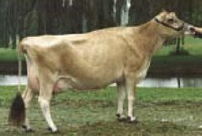

Junior Yearling

**4th Dam: Gil-Bar Unique Bonnie**

USA 3198097 7-02 EX-94 2E

WDE Grand Champion – 1986

**Family Hill Ringmaster**

USA 113790870

USDA -1507M -14F -25P 95%R 12/10

AJCA +.2T -61JPI

**Matlocks Duke Silver Beatrice**

USA 115459085

*Note: Herd Not on Test*

*22*



**Matlocks MD Silver Bumble Bea**

Born 4/15/2010 USA 117154865

**Meadow Lawn J Imperial 5OR-ET**

CAN 137656

USDA -1235M -21F -27P 99%R 12/10

AJCA -.3T -75JPI

**Pleasant Nook F Price Circus**

CAN 10203736 9-08 EX-97

4-06 2x 305 22,000 4.9 1087 3.6 799

6-04 2x 305 22,920 4.5 1038 3.5 813

**Elliots Renaissance Duke-ET**

USA 110760740

USDA -1867M -73F -56P 98%R 12/10

AJCA +0.1T -208JPI

**Nabholz Silverbullet Day**

USA 111393769

*Note: Herd Not on Test*

*Marty Matlock*

*2600 S CR 500 W*

*New Castle, IN 47362*

*317-538-1498*

*Gil-Bar Unique Bonnie*

***4th Dam Lot 21***



Senior Calf

**WF Amadeo Shyster**

USA 114957478

Parent Average:

-1142M -35F -32P

+.4T -50JPI

**Kipps V Ammie**

USA 114386139 4-06 EX-90

3-03 2x 305 17,920 4.6 821 3.4 614

4-03 2x 162 10,700 5.1 541 3.8 411

*23*



**Kipps S Ameilia**

Born 9/10/2010 USA 117496255

**Piedmont Grove Amedeo**

CAN 139523

USDA -1475M -55F -49P 92%R 12/10

AJCA +.7T -97JPI

**Hermitage Counciller Sheba**

CAN 10210999 EX-96

6-08 2x 305 23,490 4.4 1042 3.7 873

**Kipps R Victory**

USA 112700520

Parent Average:

-892M -14F -29P

-.1T -47JPI

**B Angelica of Kipps**

USA 113327135 3-04 VG-85

5-04 2x 305 16,910 4.1 695 3.4 569

6-04 2x 305 18,480 3.7 687 3.3 611

*Tom Kipp*

*1654 Hwy. 61-151*

*Hazel Green, WI 53811*

*920-248-1778*

**3rd Dam: Gloamin Juno Ameila**

CAN 605176 EX-93

7-09 2x 305 28,760 4.1 1174 3.4 986

9-08 2x 305 25,970 4.3 1119 3.4 893

**4th Dam: Gloamin Rocky Alice 3OU**

CAN 541486 EX-94 Sup EX

11-01 2x 305 14,541 3.9 577 3.8 553

**5th Dam: Gloamin Jesse Betty**

Sup EX

LFT 144,015 4.3 6297 3.4 5000

**Huronia Connect Napoleon 3U-ET**

CAN 9811343

Parent Average:

-1491M -16F -33P 36%R

**SV Jade Sammie**

USA 113790311 3-06 EX-90

1-10 2x 305 12,630 5.3 667 3.7 470

2-11 2x 305 15,220 5.3 810 3.9 601

4-00 2x 305 19,150 5.4 1032 3.8 725

5-03 2x 305 14,520 5.4 784 4.1 595

*24*



**Kipps N Suzy**

Born 12/10/2010 No. Pending

**Giprat Belles Connection-ET**

CAN 10203359

USDA -1020M +8F -21P 97%R 12/10

AJCA +1.8T +17JPI

**Huronia Imperial Nan 13A**

CAN 574227

**Giprat Belles Jade-ET**

CAN 10008436

USDA -960M -4F -22P 99%R 12/10

AJCA +1.1T +16JPI

**Prime Jason Sammie**

USA 110432258 4-05 EX-92

3-01 2x 305 9,340 5.3 496 4.2 390

4-04 2x 300 11,800 5.4 639 4.2 501

5-04 2x 305 11,100 5.2 574 4.3 475

7-02 2x 245 9,140 6.0 551 4.4 403

*Tom Kipp*

*1654 Hwy. 61-151*

*Hazel Green, WI 53811*

*920-248-1778*

Junior Yearling

Intermediate Calf

**Griffens Governor-ET**

USA 115087248

USDA -316M +7F -9P 95%R 12/10

AJCA +1.6T +11JPI

**Sooners Barber Lane**

USA 113306617 3-01 VG-86

2-10 2x 305 17,220 5.2 894 3.8 648

3-10 2x 305 16,860 4.9 827 4.0 668

6-02 2x 305 17,100 4.7 811 3.9 660

*25*



**Hubbells Gov. Bee**

Born 3/8/2010 USA 117349021

**Lester Sambo**

USA 658836

USDA -403M -7F -13P 99%R 12/10

AJCA +1.6T -5JPI

**Llolyn Jude Griffen-ET**

CAN 10211882 EX-95

5-00 2x 305 27,980 5.2 1456 3.5 978

6-11 2x 305 24,470 4.6 1129 3.4 826

**Soldierboy Boomer Sooner of CJF**

USA 640211

USDA +67M -36F -14P 99%R 12/10

AJCA +.2T -64JPI

**Barbers Karl Ariel**

USA 110313238 2-11 VG-88

2-05 2x 305 15,700 4.5 701 3.5 543

3-08 2x 290 17,870 4.3 767 3.5 618

4-08 2x 296 18,480 4.1 757 3.6 664

*Keith Hubbell & Family*

*5158 E 200 N*

*Brownsville, IN 47325*

*765-265-3133*

**3rd Dam: SV Jason Sammie**

USA 3889281 5-09 EX-90

3-08 2x 303 13,070 5.5 722 4.5 585

**4th Dam: Danum Valley Imperial Sophia**

VG-86

**5th Dam: SV Juno Sherry**

VG-84



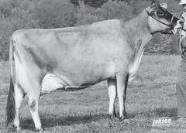

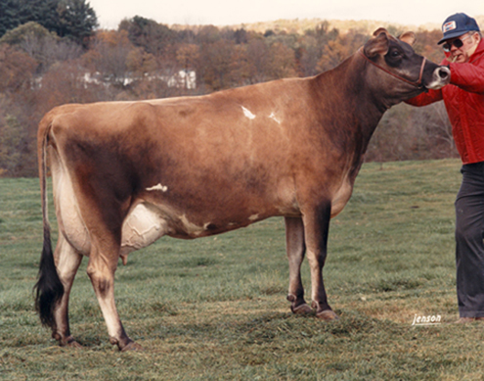

**3rd Dam: Norval Acres Jodys Delcy 4U**

USA 3703238 8-06 EX-90

**4th Dam: Norval Acres Kings Delcy 4N**

CAN 500533 5-01 EX-90 2E

**5th Dam: Norval Acres Kings Delcy 4N**

10-01 SUP-EX-2E

**6th Dam: Norval Acres Empires Dell 32K**

4-01 EX-91

**7th Dam: Norval Acres Beacon Adelle 23H**

3-08 EX-93

**8th Dam: Brampton Sleeping Beacon**

10-00 SUP-EX-90

**9th Dam: Brampton Sleeping Bijou**

25-09 SUP-EX-91

**10th Dam: Rothesay Acme of Bijou**

31-05 SUP-EX-90

**11th Dam: Brampton B P of Bijou**

3-05 EX-90

**12th Dam: Brampton Bijou Beacon**

EX-90

**13th Dam: Brampton Bijou Basil**

EX-90

**14th Dam: Brampton Bijou Pinn**

EX-90

**Vindication**

USA 113076851

USDA -1071M -39F -35P 98%R 12/10

AJCA +.4T -25JPI

**Billings Berretta Dart**

USA 113091218 6-05 EX-90

1-11 2x 291 12,350 5.6 689 3.7 455

2-11 2x 258 10,400 5.8 602 3.9 408

3-11 2x 293 11,860 5.4 641 3.8 449

4-10 2x 305 14,360 5.9 841 4.0 577

5-11 2x 305 18,770 5.2 970 3.9 741

7-04 2x 305 17,200 5.4 931 3.6 621

*27*



**Billings Vindication Diedra**

Born 4/13/2010 USA 117168688

**Bonnyburn Ali Whistler**

CAN 139270

USDA -1237M -58F -40P 94%R 12/10

AJCA -.7T -127JPI

**Huronia Centurion Veronica 20J**

CAN 10206465 EX-97

4-09 2x 365 24,568 5.7 1399 4.0 977

6-08 2x 365 24,442 5.6 1380 3.9 955

**Mason Boomer Sooner Berretta**

USA 651835

USDA -42M -29F +6P 99%R 12/10

AJCA +.6T +31JPI

**Billings Lester Darlyne**

USA 3849420 12-05 EX-94 4E

8-00 2x 304 15,350 5.3 812 3.5 544

10-03 2x 305 16,930 5.4 910 3.6 614

11-10 2x 305 17,530 5.4 946 3.6 630

*The Billings Farm*

*PO Box 489*

*Woodstock, VT 05091*

*802-457-2355*

Junior Yearling

**Bridon Excitation**

CAN 8572453

USDA -1137M -30F -39P 95%R 12/10

AJCA +1.4T -87JPI

**Rosannes Royalty of Billings-ET**

USA 112878414 3-10 EX-90

2-00 2x 305 14,560 5.2 750 3.7 532

3-05 2x 305 17,760 4.9 873 3.4 607

*26*



**Four (4) #1 DT Embryos**

**Lester Sambo**

USA 658836

USDA -403M -7F -13P 99%R 12/10

AJCA +1.6T -5JPI

**Jasper Renaissances Evening**

CAN 599920

**Sooner Centurion-ET**

USA 655767

USDA -152M +3F -1P 99%R 12/10

AJCA +1.3T +3JPI

**Juno Rosanne of Nettle Creek-ET**

USA 4010124 11-07 EX-91 2E

1-11 2x 305 13,370 5.2 700 4.0 529

3-6 2x 305 16,390 4.7 776 3.9 643

5-03 2x 305 19,670 5.6 1097 3.7 733

6-11 2x 305 16,290 5.2 851 3.9 630

10-09 2x 64 3,890 6.9 289 2.8 110

*The Billings Farm*

*PO Box 489*

*Woodstock, VT 05091*

*802-457-2355*

**3rd Dam: Billings Top Rosanne**

USA 3376974 4-07 EX-96

6-07 2x 305 19,490 5.8 1138 4.1 802

8-11 2x 305 16,810 5.5 931 3.9 655

**4th Dam: Billings TC Rose**

USA 3119214 6-00 EX-95

4-05 2x 305 14,580 6.0 876

**5th Dam: Vaucluse Surville Stella Rose**

USA 2873479 5-08 EX-90

7-01 2x 224 9,290 6.0 562

**6th Dam: Golden Jesters Star**

USA 2571130 EX-92

8-02 2x 305 12,970 5.2 679

**7th Dam: Chiefs Advancer Jester Rose**

USA 2252753 EX-92

**Note: Next three (3) dams scored Excellent!!**

***Billings TC Rose – 4th Dam Lot 25***

***Billings Top Rosanne – 3rd Dam Lot 25***



***SHF Renaissance Faline-ET***

***Dam of Lot 27***

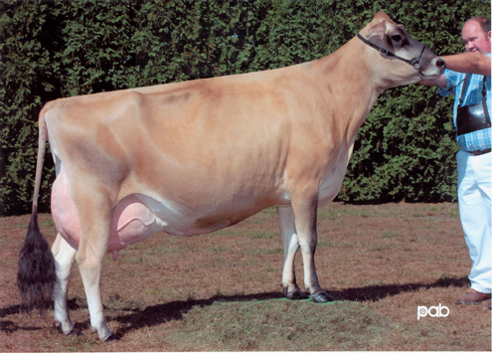

Junior Calf

**3rd Dam: Imperial Frost of SSF**

USA 3739077 3-07 EX-90

2-01 2x 305 15,990 4.6 738 3.8 606

**Forest Glen Avery Action-ET**

USA 111023978

USDA +159M +4F +4P 99%R 12/10

AJCA +1.9T +91JPI

**SHF Renaissance Faline-ET**

USA 112096197 7-06 EX-95 4E

4-03 2x 305 20,680 4.0 831 3.5 720

5-05 2x 305 17,800 4.2 739 3.4 611

7-03 2x 305 24,820 4.3 1060 3.3 829

8-11 2x 305 23,170 3.7 866 3.4 781

*28*



**Four (4) #1 DT Embryos**

**Bankcrest Lester Avery**

USA 659230

USDA -191M -5F -8P 99%R 12/10

AJCA +1.0T +37JPI

**Wolf River Berretta Addie-ET**

USA 3925986 2-03 EX-90

2-00 3x 305 25,720 4.3 1106 3.7 956

**Holly Lane Renaissance**

CAN 138720

USDA -1370M -62F -44P 97%R 12/10

AJCA +.9T -117JPI

**Sooner Frosty**

USA 3839224 7-11 VG-88

3-11 2x 299 19,730 4.6 902 3.2 631

4-11 2x 305 19,470 4.8 933 3.5 676

6-03 2x 305 20,760 4.9 1016 3.4 715

*The Billings Farm*

*PO Box 489*

*Woodstock, VT 05091*

*802-457-2355*

**Duaiseoir Example**

USA 116432135

Parent Average:

-1499M -60F -43P

+.3T -115JPI

**Master Regal Butterfly**

USA 116133858

*Note: First Calf*

*Tall Young Cow*

*Nice Udder*

*29*



**DA Example Sydney**

Born 3/2/2011 No. Pending

**Shamrock Duaiseoir-ET**

CAN 10029254

USDA -1655M -80F -51P 97%R 4/10

AJCA +.3T -153JPI

**Responses Cheryl**

USA 110822574 EX-95

**Master Milestone C**

USA 621875

**Avonlea Regal Sydney**

USA 604925

*Mesmer’s Jerseys*

*Danny Messmer*

*4240 Lou Gap Rd.*

*Martinsville, IN 46151*

*317-446-2669*



***Aland Perimeter Nan***

***3rd Dam***

***Lot 27***

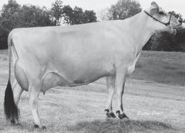

Intermediate Calf

Senior Calf

**3rd Dam: Aland Perimeter Nan**

9-10 EX-95

**Janes Primetime Justice-ET**

USA 114383583

USDA -1489M -42F -48P 72%R 4/09

AJCA +0.5T -136JPI

**Centurion Gustav Sassy**

USA 116133867 2-00 GP-81

Projected ME:

2-03 17,645 4.8 847 4.2 741

*31*



**Gustav Justice S Jan**

Born 6/6/2010 No. Pending

**Gil-Bar Sparkler Primetime**

USA 663520

USDA -1583M -27F -36P 87%R 4/09

AJCA +1.3T -44JPI

**Edgeview Renaissance Jane 57**

CAN 602548

5-06 2x 365 24,794 4.9 1223 3.7 924

**Sooner Centurion-ET**

USA 655767

USDA -152M +3F -1P 99%R 12/10

AJCA +1.3T +3JPI

**Edgebrook Gustav Janis**

7-00 GP-84

Projected ME:

18,465 5.1 942 4.3 794

*Mesmer’s Jerseys*

*Danny Messmer*

*4240 Lou Gap Rd.*

*Martinsville, IN 46151*

*317-446-2669*

**Renmoor Heather Blend**

USA 654856

**Schulte Bros Co Nan-ET**

USA 116075747

*1st Winter Yearling – 2009 IN State Fair*

*30*



**Nan Blends Heather**

Born 9/2/2010 No. Pending

**Judys Imperial Surville**

USA 626550

**Echobrook LB Heather 5P**

VG-88

9-06 2x 178 10,170 4.7 479 3.5 401

**Bridon Remake Comercia-ET**

USA 8422994

USDA -1191M -12F -34P 98%R 12/10

AJCA +1.7T 200JPI

**Aland Nanette WNL-ET**

USA 113430451 EX-90

2-02 2x 300 16,556 3.7 619 3.5 584

3-05 2x 293 16,926 3.6 612 3.9 660

*Messmer’s Jerseys*

*Danny Messmer*

*4240 Lou Gap Rd.*

*Martinsville, IN 46151*

*317-446-2669*



Summer Calf

**3rd Dam: Dexter Skyline Honey**

USA 6844323 5-00 VG-88

4-10 2x 305 20,980 3.0 632 3.5 743

6-01 305 23,820 3.2 761 3.3 786

**VWF Beacon Regal**

USA 115598625

Parent Average:

-1679M -52F -50P

-0.5T -137JPI

**Bachelors Emnem Honeycomb 915**

USA 67008915 2-07 GP-80

*34* 



**Geisler BR Honeydew**

Born 6/21/2010 Number Pending

**Remake Joe**

USA 666810

Parent Average:

-769M -15F -20P

+.1T -22JPI

**Regalman Judith**

USA 110550053 VG-88

*Note:*

*Daughter – Edith EX-93*

**Bachelors Extreme Emnem 4**

USA 112169536

Parent Average:

-858M -42F -34P

-0.2T -117JPI

**Bachelors Jude Honeybee 784**

USA 112015677 2-03 G-77

2-00 2x 305 13,750 4.5 625 3.7 505

4-00 2x 282 15,510 4.6 720 3.8 587

5-00 2x 242 9,160 3.9 359 4.0 367

*Roger Geisler*

*10448 N 700 W*

*Delphi, IN 46923*

*574-870-4588*

Summer Calf

**SHF Centurion Sultan**

USA 110404026

USDA -55M +23F +3P 99%R 12/10

AJCA +1.7T +41JPI

**RJF Big Time Brittney**

CAN 7858465 3-08 VG-87

*33* 



**Name & No. Pending**

Born 6/19/2010

**Sooner Centurion-ET**

USA 655767

USDA -152M +3F -1P 99%R 12/10

AJCA +1.3T +3JPI

**Potwell Judes Success 21C**

USA 3968887 6-09 EX-93 3E

2-05 2x 305 14,900 5.5 820 3.8 562

3-05 2x 305 15,690 5.2 822 3.9 613

**Blackys Big Time-ET**

USA 111521944

USDA -374M +17F -3P 99%R 12/10

AJCA +0.5T -41JPI

**RJF Juno Bunny**

CAN 606061 Not Classified

*Springbrook Farms*

*Mike & Todd Jones*

*760 E 450 N*

*Marshall, IN 47859*

*765-597-2058*

**3rd Dam: Juno Perfect Aurora**

13-04 EX-92

10-03 3x 305 23,320 5.2 1209 3.6 841

11-09 3x 305 19,150 2.7 1084 3.7 700

Summer Calf

**VWF Beacon Regal**

USA 115598625

Parent Average:

-1679M -52F -50P

-0.5T -137JPI

**Predestination Remake Angel VWF**

USA 115069152

*32*



**VWF Regal Remake Amelia**

Born 12/2/2010 USA 117475634

**Remake Joe**

USA 666810

Parent Average:

-769M -15F -20P

+.1T -22JPI

**Regalman Judith**

USA 110550053 VG-88

*Note:*

*Daughter – Edith EX-93*

**Predestination Viper**

USA 113935200

**Remake Perfect Allison**

USA 110980751

*Note:*

*Three (3) Full Sisters Scored EX-91, EX-91, EX92*

*Valley-Way Farms, INC*

*Roger Pyle*

*351 Koch Road*

*Rockford, OH 45882*

*419-924-1618*

**Sunset Canyon Mecca-ET**

USA 111103085

USDA +582M +55F +8P 99%R 12/10

AJCA +.7T +48JPI

**RMA Jessie**

USA 115357105

*35*



**Alaca Pixie Fae**

Born 11/1/2009 USA 117027859

*Pasture Exposed to Holstein Bull March 5*

**Rock Maple Brook Mannix**

USA 660210

USDA +578M +15F +11P 99%R 12/10

AJCA -.4T -19JPI

**Tenn Haug E Maid**

USA 3775503 EX-93

5-00 2x 16,570 7.3 1208 4.5 740

6-00 2x 365 24,014 7.0 1820 4.3 1107

**Lester Sambo**

USA 658836

USDA -403M -7F -13P 99%R 12/10

AJCA +1.6T -5JPI

**Lady Genieve**

USA 114380713

*Grant & Clay Cantwell*

*16704 Clay Street*

*Hebron, IN 46341*

*219-808-2229*

Senior Yearling



**Bachelors Jade Moby 9**

USA 112629186

Parent Average:

-1262M -26F -36P

+.2T -72JPI

**Sussex Ben 104**

USA 115069152

*37*



**Wacks Bravo Sooner Bambi**

Born 4/27/2009 USA 116640914

*Bred February 17 to Lexington*

**Giprat Bells Jade-ET**

CAN 10008436

USDA -960M -4F -22P 99%R 12/10

AJCA +1.1T +16JPI

**Pleasant Ridge TG Mona**

USA 3890340 EX-91

5-07 2x 15,340 4.6 707 3.7 570

7-00 2x 304 2x 17,490 4.8 834 3.4 588

**Barmore Berretta Ben-ET**

USA 111397763

Parent Average:

-36M -22F +3P

+.2T +22JPI

**Sussex Glenwood Bravo Sooner**

USA 111429569 2-09 G-78

2-00 2x 305 12,350 4.2 519 3.4 420

3-00 2x 68 2,720 4.3 118 3.2 86

*Grant & Clay Cantwell*

*16704 Clay Street*

*Hebron, IN 46341*

*219-808-2229*

**Forest Glen Avery Action-ET**

USA 111023978

USDA +159M +4F +4P 99%R 12/10

AJCA +1.9T +91JPI

**Predestination Remake Angel VWF**

USA 115069152

*36*



**Penolope Choice**

Born 1/1/2009 USA 116768036

*Pasture Exposed to Holstein Bull March 3*

**Bankcrest Lester Avery**

USA 659230

USDA -191M -5F -8P 99%R 12/10

AJCA +1.0T +37JPI

**Wolf River Berretta Addie-ET**

USA 3925986 2-03 EX-90

2-00 3x 305 25,720 4.3 1106 3.7 956

**Dements master Harry**

USA 110328548

USDA -117M -55F -48P 58%R 12/10

AJCA -124JPI

**Tiphat Audry Addie of M&M**

USA 111559756

*Grant & Clay Cantwell*

*16704 Clay Street*

*Hebron, IN 46341*

*219-808-2229*

Senior Two

Junior Two



**O.F. Barber Rocket**

USA 110437084

USDA -148M -11F -3P 99%R 12/10

AJCA +1.3T +35JPI

**Lady Genieve**

USA 114380713

*39*



**Lady Delight**

Born 5/10/2009 USA 116768027

*Bred March 3 to Lyndon (sexed)*

**WF/L&M Duncan Barber-ET**

USA 654600

USDA +57M +8F -7P 99%R 12/10

AJCA -.1T -10JPI

**O.F. Berretta Rebekah**

USA 3889474 EX-90

2-10 2x 305 20,470 4.8 975 4.0 826

3-10 2x 305 20,420 4.8 975 4.1 838

**Sussex Halmark Cody**

USA 112627326

Parent Average:

+530M +7F +17P

+.9T +54JPI

**HJ Poseidon Duncan Sprite**

USA 110802552 2-07-VG-85

1-11 2x 305 16,730 4.5 761 3.3 557

2-11 2x 305 19,060 4.8 920 3.3 637

4-00 2x 172 13,180 4.7 620 3.3 429

*Grant & Clay Cantwell*

*16704 Clay Street*

*Hebron, IN 46341*

*219-808-2229*

**Sunest Canyon Matinee-ET**

USA 111981214

USDA +1006M +96F +34P 99%R 12/10

AJCA -.2T +145JPI

**Gordons Dan Molly**

USA 115735815

*38*



**Alaca Dolly Mae**

Born 12/5/2009 USA 117027877

*Pasture Exposed to Holstein Bull March 3*

**Walden Farm Mr T Quest Angel-ET**

USA 663363

USDA +131M +17F +0P 99%R 12/10

AJCA +.7T +4JPI

**Tenn Haug E Maid**

USA 3775503 EX-93

5-00 2x 16,570 7.3 1208 4.5 740

6-00 2x 365 24,014 7.0 1820 4.3 1107

**Gordons Thundering Dan**

USA 113580996

Parent Average:

-1235M -36F -37P

**Gordons BT Mindy**

USA 113580996 4-02 VG-87

*Grant & Clay Cantwell*

*16704 Clay Street*

*Hebron, IN 46341*

*219-808-2229*

**BW Carrier-ET**

USA 116432135

USDA +1336M +16F +29P 91%R 12/10

AJCA +.9T +90JPI

**KKF Pansy R Master Philly**

USA 116090287 2-02 G-76

2-00 2x 295 14,650 5.4 792 3.8 561

*40*



**KKF Philly Carrier Pretzel**

Born 4/12/2010 USA 117178658

**Sunbow Rueben**

USA 666362

USDA +1369M +6F +29P 99%R 12/10

AJCA -.1T +38JPI

**BW Avery Katie ET121-ET**

USA 110834153 EX-93

6-06 3x 365 36,530 4.8 1747 3.2 1172

8-02 365 3x 35,240 4.4 1533 3.2 1128

**Family Hill Ringmaster**

USA 113790870

USDA -1507M +14F -25P 95%R 12/10

AJCA +.2T +61JPI

**KKF Pert Parade Pansy**

USA 113433276 5-03 VG-85

4-00 2x 305 21,850 4.3 935 3.9 857

5-00 2x 305 23,050 4.7 1077 3.9 906

6-01 2x 305 19,450 4.8 930 3.9 762

7-03 2x 94 4,510 4.7 210 4.3 192

*Snider Farms & Families*

*Scott Snider*

*70985 CR 19*

*New Paris, IN 46553*

*574-831-6992*

Intermediate Yearling

Junior Two



*Milking Shorthorns*



*42*



**B-D-F J-Boy Susan**

Born 12/18/2009 USA 68305273

**B-D-F Jewel’s Boy**

USA 463614

Parent Average:

+31M +7F -1P -45NM

-0.5PL 3.18SCS -0.3DPR

**B-D-F Flash Sarah**

USA 471000411 8/29/2007

Not Classified

**Mericrest Now You See**

USA 436837

PTA +20M +5F +1P -102NM

PTA -0.4PL 3.44SCS -0.5DPR

**Othello Rubys Jewel**

USA 460853 6-05 EX-92 2E

3-09 2x 345 35,220 6.0 2098 3.1 1088

**Landrums Royal Flash**

USA 450281

Parent Average:

-399M -19F -16P -147NM

-1.4PL 3.03SCS +0.5DPR

**Grade Milking Shorthorn**

*Lattire’s Twilite Farm*

*Richard Lattire*

*6653 Kaiser Dr.*

*Lawrenceburg, IN 47025*

*812-926-0519*

Intermediate Yearling

Junior Yearling

*41*



**SF After Ron Iva**

Born 5/20/2010 USA 68306815

**Halpins Morning After-ET**

USA 463018

*PTA -88M -10F -9P -93NM*

*-.4PL +3.07 SCS -.2DPR*

**SF Ron Inze-EXP**

USA 467973 Not Classified

2-01 305 2x 10,510 3.5 365 3.1 331

**Hilltop Academy**

USA 441898

PTA -8M -11F -4P -69NM

-.9PL +2.98SCS -.1DPR

**H.C.T.H. Rebel Martini**

USA 449493 EX-90

2-03 299 2x 17,124 3.9 662 3.4 589

**Glenrich R.6. Ron**

USA 461249

Parent Average:

-289M -11F -9P -140NM

-1.9PL +3.12SCS +.3DPR

**SF Ralph Ixonia**

USA 360011644 Not Classified

1-11 305 2x 11,140 3.9 431 3.2 356

*Samuelson Farms*

*Wendell Samuelson*

*7009 Queen Rd*

*Plymouth, IN 46563*

*574-936-9601*



Intermediate Calf

*43*



**Glenrich Cherrie 63**

Born 12/25/2010 Number Pending

**Blue Spruce Mean Mr Mustard**

USA 465236 Not Classified

PTA -41M -11F -6P -73NM

PTA -.08PL 2.98SCS -.1DPR

**Glenrich Cherri 49**

USA 463374 Not Classified

**Hilltop Academy**

USA 441898 Not Classified

**Bluespruce-Kaclay Misty Melody**

USA 455737 3-04 VG-87 VVVGE

2-08 2x 313 20,310 3.6 735 3.3 663

3-08 2x 360 22,270 3.6 750 3.1 653

**Twilite Dillys Willy**

USA 458628 Not Clasified

Parent Average:

-429M -13F -15P -84NM

-.9PL 2.93SCS +.7DPR

**Glenrich Cherrie 17**

USA 441538 7-05 VG-85 VVV++

6-11 2x 292 16,360 2.7 448 2.9 473

*Mark & Cynthia Mote*

*8514 E 50 S*

*Union City, IN 47390*

*765-964-3019*

Junior Calf

*44*



**Glenrich Queen 209**

Born 3/14/2011 Number Pending

**Glenrich M75 Parti-Time**

USA 68304615 Not Classified

Parent Average:

-393M -18F -12P -145NM

-1.8PL 3.06SCS +.5DPR

**Glenrich Queen 195**

USA 471000286 Not Classified

**Gold-Brook Parti-Time-ET**

USA 459179 Not Classified

PTA -289M -19F -7P-54NM

PTA +0.0PL 3.05SCS +.5DPR

**Glenrich Venus Mary 75**

USA 450695 Not Classified

**Twilite Dillys Willy**

USA 458628 Not Classified

Parent Average:

-429M -13F -15P -84NM

-.9PL 2.93SCS +.7DPR

**Glenrich Queen 180**

USA 463462 Not Classified

*Mark & Cynthia Mote*

*8514 E 50 S*

*Union City, IN 47390*

*765-964-3019*





*Guernsey*

*45*



**For Lou Farms GL Joy**

Born 12/17/2008 USA 68021191

*Bred to Molehill Showtime Donnovan*

**Rozelyn Patmar Jay Glacier-ET**

USA 602961

PTA -91M +15F +6P 97%R 12/10

PTA +195NM +.18%F +.09%P

PTA +2.3PL +.5DPR

PTA +.6T +.8UDC -.4FLC

**For Lou Farms Les Jody**

USA 68007775 4-00 GP-83

2-05 2x 365 16,790 4.7 792 3.1 523

3-06 2x 305 14,280 4.6 654 3.4 484

**Rozelyn Prince Jay-ET**

USA 600064

PTA -265M +4F +16P 98%R 12/10

PTA -75NM +.09%F +.15%P

PTA -1.2PL +.2DPR

PTA -1.7T -2.2UDC -1.4FLC

**Rozelyn Patmar P Gina-ET**

USA 3010608 3-07 EX-90

3-05 2x 365 22,460 5.4 1217 4.2 951

**Flambeau Manor Tiller Les-ET**

USA 604826

PTA -19M +23F -2P 89%R 12/10

PTA +143NM +.14%F -.01%P

PTA +2.1PL -.9DPR

PTA +.3T +2.0UDC +.2FLC

**For Lou Farms Super Jill**

USA 68000341 2-07 G-74

1-11 2x 283 8,430 3.9 327 2.7 230

*Paul Nicely*

*4690 W 200 N*

*Lebanon, IN 46052*

*317-919-1459*

Summer Yearling

Senior Two

*46*



**For Lou Farms AS Cookie**

Born 8/14/2009 USA 68030004

**Sniders Ronalds Alstar**

USA 604761

PTA +1078M +43F +24P 85%R 12/10

PTA +488NM -.03%F -.06%P

PTA +4.9PL +2.3DPR

PTA +.5T +.3UDC +1.8FLC

**For Lou Farms Les Cubie**

USA 68007768 3-05 GP-83

3-03 2x 308 10,460 5.4 560 3.7 392

4-03 2x 285 11,710 5.2 605 3.7 429

**Marodore Goliaths Ronald-ET**

USA 603218

PTA +209M +15F +5P 97%R 12/10

PTA +191NM +.03%F -.01%P

PTA +1.7PL +2.2DPR

PTA -.8T -.2UDC -.5FLC

**Cedar Fringed Altann**

USA 3045188 6-11 EX-95 GSD

3-05 2x 365 22,460 5.4 1217 4.2 951

**Flambeau Manor Tiller Les-ET**

USA 604826

PTA -19M +23F -2P 89%R 12/10

PTA +143NM +.14%F -.01%P

PTA +2.1PL -.9DPR

PTA +.3T +2.0UDC +.2FLC

**For Lou Farms A Cuba**

USA 32300763 4-09 G-74

2-09 2x 305 11,410 5.8 662 3.8 436

4-05 2x 325 10,180 5.7 580 3.9 400

5-06 2x 256 10,840 5.8 626 3.7 401

*Paul Nicely*

*4690 W 200 N*

*Lebanon, IN 46052*

*317-919-1459*



Senior Calf

*47*



**Molehill Donovan Allie**

Born 9/5/2010 USA 680443186

**Molehill Showtime Donovan**

USA 6802786

PTA -247M -6F -6P

PTA +31NM +.03%F +.02%P

PTA +1.4PL +.3DPR

PTA +.2T +.1UDC +1.4FLC

**Braswell Gabrials Aleasa**

USA 3070278 5-02 G-79

2-05 2x 305 18,230 3.2 591 3.0 542

**Four Winds Showtime-ET**

USA 68002690

PTA -836M -32F -18P 85%R 12/10

PTA +2NM +.03%F +.06%P

PTA +3.1PL -.3DPR

PTA +.2T +.9UDC +2.5FLC

**Dutch Mills Logic Donna**

USA 3069063 5-02 EX-90

3-03 2x 365 24,730 4.8 1184 3.3 817

**Briarcreek Goliath Gabrial**

USA 603320

PTA -1.6T -.5UDC -.8FLC 50%R 12/10

**Braswell Ideals Athena**

USA 3011509 9-06 GP-83

5-03 2x 305 17,860 4.2 747 3.5 633

8-00 2x 305 17,030 3.8 649 3.3 566

LFT 2029 102,960 4.0 4118 3.5 3576

*David Croshaw*

*3050 Chestnut Grove*

*Porksville, KY 40464*

859-583-6682





*Brown Swiss*

Summer Calf

Intermediate Calf

*48*



**Bless-Caff Starsky Caroline**

Born 12/15/2010 USA 68126589

**Old Mill TA Starsky ET**

USA 197921

PTA -691M -3F -5P +61NM

PTA +1.9PL 3.00SCS +0.2DPR

**Bless-Caf Agenda Classic ET**

USA 68107466 1-11 VG-85 ++VVV

**Mort Jade Starbuck**

USA 184087

PTA -779M -25F -23P -16NM

PTA +3.0PL 3.21SCS +1.0DPR

**Old Mill E Snickerdoodle**

USA 883215 12-00 EX-94 2E EEEEE

LFT 2434 188,140M 8679F 6945P

*Eight time all American*

*WDE Supreme Champion 2003*

**Blessing Banker Agenda-ET *TM**

USA 194882

PTA -496M +22F +0P +163NM

PTA +2.3PL 2.89SCS -0.6DPR

**Sems Jetway Susie Carol**

USA 865587 11-3 VG-88 EVVVV

1-10 2x 365d 22,340 4.0 905 3.6 802

5-01 2x 365d 28,070 4.2 1166 3.2 905

*Brent Caffee*

*3736 N 200 W*

*Decatur, IN 46733*

260-301-1092

**3rd Dam:** SEMS Jubilation Susie Carol

6-08 EX-90 EEEVE

4-00 2x 22,770 4.4 1010 3.7 841

6-07 2x 21,080 4.7 1001 3.8 804

**4th Dam:** SEMS Elegant Susie Carol

VG-87

3-02 2x 17,110 4.7 810 3.6 616

*49*



**Bless-Caff Tressel Amber**

Born 8/6/2010 USA 68124039

**Savage-Leigh Tressel ET *TM**

USA 199115

PTA -437M -18F -15P -120NM

PTA -1.0PL 2.97SCS +0.4DPR

**Bless-Caff Zeus Ava**

USA 68101187 Not Classified

**Top Acres E P Premium QS-ET**

USA 191362

PTA +355M +17F +10P +262NM

PTA +2.9PL 2.92SCS +0.9DPR

**GS FLJ Tippy-ET**

USA 865736 2E94 2E93MS

8-00 2x 365 33,720 3.9 1316 3.1 1046

**Red Brae Prelude Zeus (M)**

USA 193849

PTA -640M +5F -1P +154NM

PTA +1.3PL 2.82SCS +0.9DPR

**Bless-Caff Dynasty Alli-ET**

USA 942065 4-10 VG-86 +E+GE

2-09 2x 305 16,400 4.3 708 3.1 513

*Brent Caffee*

*3736 N 200 W*

*Decatur, IN 46733*

260-301-1092



Senior Two

*50*



**Niermans P Surge Dana**

Born 12/12/2008 USA 68106827

*Bred 9/16/2010 to Twinkle Hill Dynasty Alloy*

**Top Acres Power Surge *TM**

USA 196004

PTA +913M -1F +24P +130NM

PTA +2.4PL +3.23SCS +0.3DPR

**Niermans Coin Dusty**

USA 935174 4-02 VG-85 VV++V

2-01 2x 305 13,270 4.5 595 3.5 469

3-03 2x 316 16,360 4.4 723 3.7 599

**Top Acres Jet Power-ET(M)**

USA 191610

PTA +788M +17F +10P +47NM

PTA +0.2PL 3.06SCS

**Hill-N-Dale Ensign Sue-ET**

USA 841967 EX-93 3E EEEEE

LFT 1840 162,010 6847 5610

**R Hart CB Coin**

USA 195711

PTA +118M +8F +5P -187NM

PTA -3.9PL 3.17SCS -2.1DPR

**Niermans Kirks Dede**

USA 890067 GP-83 VEE+G

3-06 2x 365 25,050 4.4 1114 3.2 792

LFT 1715 105,290 4361 3528

*Dr. Jamie Cassell*

*103 Nuckolls Curve Road*

*Galax, VA 24333*

*276-236-8518*

**3rd Dam:** Schwoeppes Moonshine

7-00 VG-87 VVVVV

10-05 2x 299 19,760 3.9 776 3.4 663

**Full Sister To Dam:**

**Schwoeppes Jetway Marie**

EX-90

LFT 120,879 4982F 4205P

*52*



**Schwoeppes Driver Marcie**

Born 7/13/2010 USA 68128814

**Hilltop Acres H Driver-ET *TM**

USA 196826 TM

PTA +657M +47F +38P

PTA +456NM +.09%F +.07%P

PTA +3.0PL 3.05SCS

PTA -.4T +.47UDC

**Schwoeppes JW Milky**

USA 68118781 Not Classified

**Hussli**

USA 196760

**Hilltop Acres Lep Diane-ET**

USA 908535

**Forest Lawn Simon Jetway-ET**

USA 185301

PTA -40M -4F -11P -285NM

-2.7PL 3.00SCS -3.0DPR

**Schwoeppes Moonbeam**

USA 867874 6-05 VG-88 EEVE+

4-04 2x 292 19,140 4.0 765 3.5 675

5-04 2x 350 23,090 3.5 817 3.2 733

6-05 2x 297 20,170 3.7 745 3.4 677

LFT 2701 164,850 5999 5547

*Schwoeppe Dairy*

*Darren & Sam Schwoeppe*

*2250 W 900 S*

*Huntingburg, IN 47542*

*812-683-4795*

Summer Calf

Junior Two

*51*



**Royal-Colors Denver Sugar**

Born 4/9/2009 USA 6110264

*Bred 9/11/2010 to Twinkle Hill Dynasty Alloy*

**Rolling View Denver-ET *TM**

USA 193557 Not Classified

PTA -7M +26F +5P +141NM

PTA +1.4PL 3.03SCS -.08DPR

**Royal-Colors Collect Sophie**

USA 954123 2-01 GP-80 G+G++

2-01 2x 318 14,330 4.8 684 3.6 519

**Betta Vue Emory Prelude-ET**

USA 187668 EX-91

PTA +162M -14F +1P -179NM

PTA -1.4PL 3.09SCS -1.7DPR

**Quincy Jetway Diane Dallas**

USA 849525 2-09 EX-90 VEVVE

2-03 2x 365 31,520 1.0 1263 3.5 1096

**R Hart BC Collection *TM**

USA 189182 EX-93

PTA +136M +10F +9P -190NM

PTA -4.0PL 3.05SCS -1.6DPR

**Rocky Haven Coco Kiss**

USA 927567 5-04 GP-82 VG+V+

4-02 2x 982 15,850 3.7 586 3.4 538

5-01 2x 305 18,990 4.3 819 3.5 663

6-02 2x 104 8,020 3.8 304 3.1 245

*Dr. Jamie Cassell*

*103 Nuckolls Curve Road*

*Galax, VA 24333*

*276-236-8518*



*55*



**Name & Number Pending**

Born 12/1/2010

**Hilltop Acres EN Dynasty-ET *TM**

USA 193371

PTA +565M -4F +12P -34NM

PTA -.1PL 3.12SCS -2.5DPR

**Rosedale Solo Z**

USA 889433 10-08 GP-81 EEVGF

5-06 2x 326 19,710 4.2 825 3.3 656

6-06 2x 349 19,350 4.0 776 3.3 643

7-07 2x 326 19,160 4.2 808 3.1 601

8-08 2x 361 20,270 4.2 849 3.3 674

LFT 2834 150,830 4.1 6196 3.3 5044

**R Hart Simon Ensign-ET**

USA 184138 VG-88

PTA +279M -20F -8P +150NM

PTA +5.1PL 2.94SCS +0.0DPR

**Hilltop Acres PT Dreamer-ET**

USA 862391

2-04 2x 267 23,760 4.0 950 3.4 796

**Emory Tammys Zoldo *TW**

USA 192805

PTA +153M +8F +5P +59NM

PTA -.3PL 3.05SCS +.2DPR

**Rosedale J K Rhythm**

USA 798955 7-02 VG-88 VVVEV

5-00 2x 305 18,210 3.7 666 3.5 632

7-01 2x 274 18,340 4.0 741 3.5 645

8-02 2x 351 20,510 3.9 799 3.6 743

LFT 2964 149,200 3.8 5609 3.6 5302

*Buckeye Knoll Dairy*

*Doug Rhoades*

*5554 Greenville Bakers Store Rd*

*Greenville, OH 45331*

937-548-0553

Intermediate Calf

Senior Yearling

Summer Calf

*53*



**Dutchman Power Marie**

Born 6/5/2010 Number Pending

**Top Acres Power Surge *TM**

USA 196004

PTA +913M -1F +24P +130NM

PTA +2.4PL +3.23SCS +0.3DPR

**Englert Manny**

USA 68106572 Not Classified

PTA +171M -4F +1P -171NM

PTA -.1PL 2.99SCS +.3DPR

**Top Acres Jet Power-ET(M)**

USA 191610

PTA +788M +17F +10P +47NM

PTA +0.2PL 3.06SCS

**Hill-N-Dale Ensign Sue-ET**

USA 841967 EX-93 3E EEEEE

LFT 1840 162,010 6847 5610

**Forest Lawn PHT Jamarr-ET**

USA 191790 GP-84

PTA +1005M +23F +13P +53NM

PTA -.1PL 2.99SCS +.3DPR

**Schwoeppes Banker Money**

USA 929620 Not Classified

3-00 2x 331 19,800 4.1 915 3.6 704

4-01 2x 287 15,700 4.4 689 3.6 571

*Dutchman Farms, INC.*

*Samuel Englert*

929 County Road 750 East  
Wadesville, IN 47638  
(812) 985-2975

**3rd Dam: Rosedale J D Melody**

USA 748019 7-05 EX-90 EEVEE *ELITE*

5-05 2x 365 20,620 3.6 739 3.4 693

8-00 2x 365 24,530 3.2 786 3.5 851

LFT 2128 125,620 3.7 4641 3.4 4265

**3rd Dam: Schwoeppes JW Moonlight**

USA 889128 6-04 EX-90 VEEVE

2-03 2x 305 16,160 4.0 648 3.3 541

3-06 2x 340 21,180 3.7 779 3.3 694

4-08 2x 295 20,050 3.6 721 3.3 652

5-07 2x 349 22,810 4.1 926 3.3 755

6-09 2x 285 21,370 4.1 866 3.1 668

7-08 2x 305 20,760 3.2 673 3.2 665

LFT 2232 136,730 5163F 4494P

*54*



**Stookeyholm Mad Fantasia**

Born 9/2/2009 USA 68115328

**Mort Starbuck Madison *TM**

USA 197117

Parent Average:

-871M -32F -24P -38NM

+3.1PL 3.07SCS +0.8DPR

**We-Gotta Jet Pilot Fidelity**

USA 926230 7-04 EX-91 EEEEE 2E

2-05 2x 350 19,920 4.5 893 3.3 660

3-06 2x 347 20,790 4.3 888 3.3 681

**Mort Jade Starbuck**

USA 184087

PTA -582M -17F -15P +31NM

PTA +3.7PL 3.19SCS +0.1DPR

**Ventures Blueyed Maggie**

USA 844672 9-00 EX-94 3E

LFT 2425 170,390 6753 5979

**Top Acres Jet Pilot ET (M*)**

USA 191611

PTA +319M +20F +5P +30NM

PTA +0.2PL 2.95SCS -1.8DPR

**We-Gotta Fragment De Fid**

USA 848970 8-00 VG-85

5-00 2x 306 16,530 4.1 678 3.1 516

6-01 2x 362 16,840 3.2 547 3.1 525

7-04 2x 305 15,840 3.7 585 2.9 465

8-06 2x 305 14,990 3.4 516 3.1 463

*Andy Keener*

*2294 W 700 N*

*Leesburg, IN 16538*

*574-453-3785*



Summer Calf

***Blessing Agenda Grace – Dam of Lot 54***

***Iroquois Acres Ensign Gidget – 2nd Dam of Lot 54***

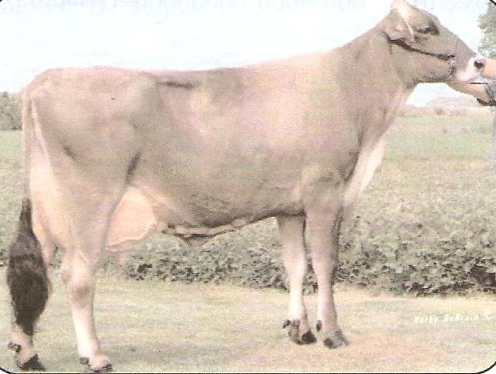

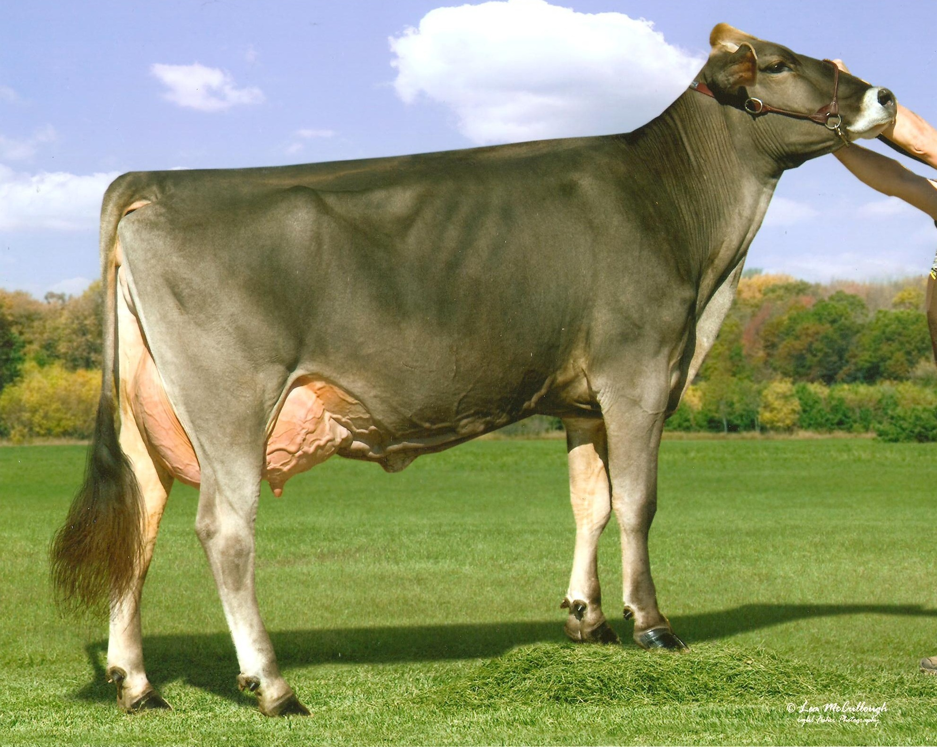

**3rd Dam: Beech Hill Stretch Gloria**

USA 853854 7-00 VG-85 V+V+V

LFT 1854 107,270 4.2 4452 3.5 3771

**4th Dam: Beech Hill Johnny D Glory**

USA 750919 VG-88

6-06 2x 305 19,720 4.2 832 3..5 691

**5th Dam: Beech Hill Kings Gloria**

USA 711698 EX-90 2E

4-03 2x 305 21,210 3.0 629 3.2 686

**6th Dam: Beech Hill Improver Glenda**

USA 678837 EX-90 3E

6-02 2x 305 22,400 3.4 752 3.2 725

*56*



**Hidden Paradise Tressel Gia**

Born 6/19/2010 USA 68128544

**Savage-Leigh Tressel ET *TM**

USA 199115

PTA -437M -18F -15P -120NM

PTA -1.0PL 2.97SCS +0.4DPR

**Blessing Agenda Grace**

USA 951493 VG-87 90MS +EGVE

*2009 Tennessee State Fair: 2nd & Best Udder Sr 2*

*2010 Kentucky State Fair: 2nd & Best Udder Sr 3*

*2010 North American: 3rd Sr 3*

**Top Acres E P Premium QS-ET**

USA 191362

PTA +355M +17F +10P +262NM

PTA +2.9PL 2.92SCS +0.9DPR

**GS FLJ Tippy-ET**

USA 865736 2E94 2E93MS

8-00 2x 365 33,720 3.9 1316 3.1 1046

**Blessing Banker Agenda-ET *TM**

USA 194882 Superior Sire

PTA +368M +42F +22P +308NM

PTA +3.1PL 2.83SCS -1.0DPR

**Iroquois Acres Ensign Gidget**

USA 883406 5-07 EX-91 EEEVE 2E

3-04 2x 365 34,280 3.7 1271 3.4 1154

5-06 2x 365 34,520 3.7 1266 3.3 1125

8-02 2x 365 31,460 3.8 1196 3.2 1002

LFT 2292 196,060 3.8 7487 3.2 6350

*David Croshaw*

*3050 Chestnut Grove*

*Porksville, KY 40464*

859-583-6682





*Ayrshires*

Senior Calf

*57*



**McCayland Recharger Mabel**

Born 9/28/2010 USA 100609064

**Covey-Farms Willy Recharger-ET**

USA 150113

PTA: +539M +5F +9P 88%R 12/10

**McCayland Trident Mustang**

USA 100366543 Not Classified

**Desblay Rebel Willy**

USA 739413c

PTA: -32M -14F +8P

**Covey-Farms A E Reality**

USA 968249 3-05 VG-86 +EV V

3-07 2x 365 26,530 3.8 999 3.5 926

9-02 2x 305 27,530 3.4 929 3.1 843

LFT 2373 171,440 3.7 6410 3.3 5616

**Ardrossan EV Kates Trident *TF**

USA 144136 12-03 EX-95 EEEE

PTA: -113M -13F +12P

**McCayland Olympic 2 Lindy Star**

USA 100395075 3-10 VG-85

*Carissa McCay*

*5409 E 17th Rd*

*Tippecanoe, IN 46570*

*219-498-6640*

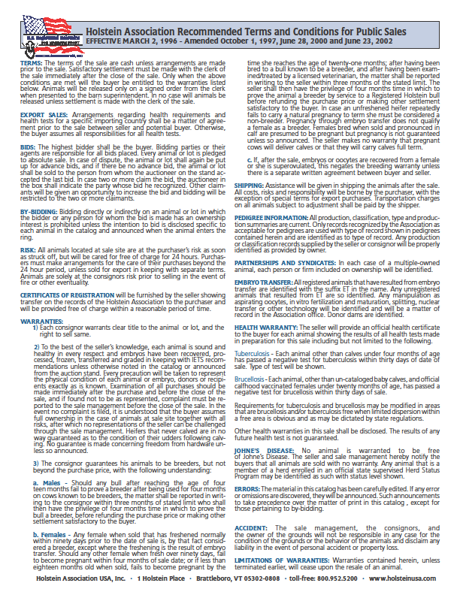

Dairy

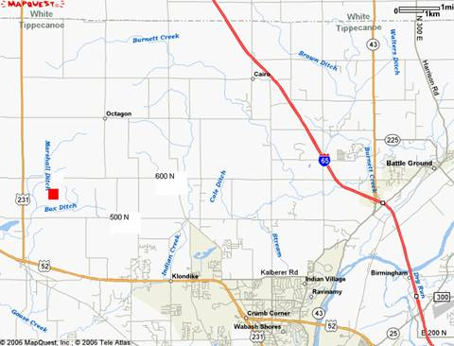

**From  Chicago :** Take I-65 South toward Indianapolis.  Exit on Highway 43  North (Exit #178, turn toward Brookston).  Go approximately 1/2 mile to stoplight (McDonalds on left, State Police Post on right) and turn left (west) onto county road 600 North.  Stay on 600 North (approximately 7.5 miles total) through two stop signs.  ASREC farms are approximately 2 miles after second stop sign.  There will be signs directing you to the sale.

**From  Indianapolis :** Take I-65 North toward Chicago.  Exit on Highway 43  North (Exit #178, turn toward Brookston).  Go approximately 1/2 mile to stoplight (McDonalds on left, State Police Post on right) and turn left (west) onto county road 600 North.  Stay on 600 North (approximately 7.5 miles total) through two stop signs.  ASREC farms should be approximately 2 miles after second stop sign.  There will be signs directing you to the sale.

**From  Lafayette and West Lafayette :** Take Highway 52 west (through West Lafayette ) out to Montmorenci and Highway 231.  Turn right onto 231 North. Follow it one mile until you reach the first intersection (county road 500 North).  Turn right (east) onto 500 North and follow it approximately 1/2 mile.  There will be a sign at the end of the farm lane that has Purdue University Animal Sciences Research & Education Center.  You must turn left onto the farm lane (there is no right turn at this intersection) in order to reach the Animal Sciences farm units. There will be signs directing you to the sale.

**From  Illinois (mid-state) :** Take Highway 26 East until you read a sign that directs you to turn north to reach Otterbein. Go straight through Otterbein until you reach Highway 52 (four lanes), then turn east.  Follow it approximately 4 miles until you reach Montmorenci.  Turn north onto Highway 231 North.  Follow it one mile until you reach the first intersection (county road 500 North).  Turn right (east) onto 500 North and follow it approximately 1/2 mile.  There will be a sign at the end of the farm lane that has Purdue University Animal Sciences Research & Education Center .  You must turn left onto the farm lane (there is no right turn at this intersection) in order to reach the Animal Sciences farm units. There will be signs directing you to the sale.

**INDEX**

**Holsteins**

A&W Holsteins AW Damion Scarlett 13

Byers, David Goldwyn Semen 12

Dankert, Jeremy Nor-Bert Marico Sophie 17

Eby, Jordan Lookwell Debonair Luna 4

Hibschman, Joe Oneeda Alexander Jade 14

Indianhead Holsteins Embryo Package 15

Indianhead Holsteins Embryo Package 16

Jones, Mike & Todd Embryo Package 10

Kron, Melvin Adler Boxer Lacy 096-ET 5

Kron, Melvin Koester Moscow Sue 0998 6

Miller, Elroy G. Elmyra Inferno Hazel-Red 11

Miller, Robert Mil-R-Mor Shottle Rhona-ET 1

Mitchell, Roy Pick of Flush 19

Oesch, Mike Ally 21

Paulus, Dennis & Brad Denwood Damion Donna 7

Reiff Farms Reiff-Farm Sanchez Spice 20

Schwoeppe, Darren & Sam Schwoeppes Septstrm Safron 18

Van Tuinen, Mark Embryo Package 2

Van Tuinen, Mark Embryo Package 3

Wicker, Douglas MS Wintrfield Jet Ronna-Red 8

Wicker, Douglas Name & Number Pending 9

**Jerseys**

Cantwell, Grant & Clay Alaca Pixie Fae 35

Cantwell, Grant & Clay Penelope Choice 36

Cantwell, Grant & Clay Wacks Bravo Sooner Bambi 37

Cantwell, Grant & Clay Alaca Dolly Mae 38

Cantwell, Grant & Clay Lady Delight 39

Geisler, Roger Geisler BR Honeydew 34

Hubbell, Keith Hubbells Gov. Bee 25

Jones, Mike & Todd Name & Number Pending 33

Kipp, Tom Kipps S Ameilia 23

Kipp, Tom Kipps N Suzy 24

Matlock, Marty Matlocks MD Silver Bumble Bea 22

Messmer, Danny DA Example Sydney 29

Messmer, Danny Nan Blends Heather 30

Messmer, Danny Gustav Justice S Jan 31

Pyle, Roger VWF Regal Remake Amelia 32

The Billings Farm Embryo Package 26

The Billings Farm Billings Vindication Diedra 27

The Billings Farm Embryo Package 28

**Brown Swiss**

Caffee, Brent Bless-Caff Starsky Caroline 48

Caffee, Brent Bless-Caff Tressel Amber 49

Cassell, Jamie Niermans P Surge Dana 50

Cassell, Jamie Royal-Colors Denver Sugar 51

Croshaw, David Hidden Paradise Tressel Gia 56

Englert, Samuel Dutchman Power Marie 53

Keener, Andy Stookeyholm Mad Fantasia 54

Rhoades, Doug Name & Number Pending 55

Schwoeppe, Darren & Sam Schwoeppes Driver Marcie 52

**Milking Shorthorns**

Lattire, Richard B-D-F J-Boy Susan 42

Mote, Mark & Cynthia Glenrich Cherrie 63 43

Mote, Mark & Cynthia Glenrich Queen 209 44

Samuleson, Wendell SF After Ron Iva 41

**Guernseys**

Croshaw, David Mole Hill Donovan Alli 47

Nicely, Paul For Lou Farms GL Joy 45

Nicely, Paul For Lou Farms AS Cookie 46

**Ayrshires**

McCay, Carissa McCayland Recharger Maybel 57

**NOTES**

**FIRST CLASS**

**Purdue Dairy Club**

915 West State Street, Lilly Hall 3rd Floor

West Lafayette, IN 47907-2054